Report

On

**APEXFLEX (GYM WEBSITE)**

Submitted to:

**Panjab University, Chandigarh**

In the partial fulfillment of the requirement for the degree of

**Bachelor of Computer Applications (B.C.A.) (Session – 2023-2024)**



**Under the Supervision of: Submitted by: Dr. Harmunish Taneja, Dr. Mandeep Gill**  **Prabhjot Singh,** **Nupur**

**Asstt. Prof. B.C.A 6 th Semester Deptt of Computer Sc. College Roll No.:**

**7018, 7056**

**University RollNo.:**

**21046716, 21046713**

**DAV COLLEGE, SECTOR 10, CHANDIGARH.**

**DAV COLLEGE, SECTOR 10, CHANDIGARH**

CERTIFICATE

DAV COLLEGE, SECTOR 10, CHANDIGARH CERTIFICATE This is to certify that Mr./Ms. ____________________________, Class Roll No.____________ a bonafide student of B.C.A. 6th Sem being run by DAV College, Chandigarh of batch 2023-2024 has completed the project entitled “_______________________________________________________” under my supervision & Guidance. It is further certified that the work done in this project is a result of candidate’s own efforts. I wish him / her all the success in his / her life. (Space for the Signature’s of the internal guide) Date: Name of the Internal Guide Asstt. Prof. Deptt. of Comp. Sc.

Date: Asstt. Prof.

Deptt. of Comp. Sc.

**ACKNOWLEDGEMENT**

The successful completion of this report on the APEXFLEX(gym website) would not have been possible without the guidance and support of several individuals.

First and foremost, I would like to express my sincere gratitude to our Project Guide, **Dr. Harmunish Taneja** and **Dr. Mandeep Gill**, appointed by the College. Their invaluable insights, constructive feedback, and unwavering support throughout the project were instrumental in shaping the direction and quality of our work. Their deep understanding of web development and project management principles has been a true asset, and we are deeply appreciative of the time and efforts that they invested in mentoring us.

I would also like to thank our Head of Department (HoD),**Dr. Minakshi Bhardwaj** , for her constant encouragement and for providing us with the necessary resources and infrastructure to undertake this project successfully. Her vision and leadership have been a driving force behind our efforts, and we are grateful for the opportunity she has given us to showcase our skills and contribute to the growth of our institution.

Moreover, I extend my heartfelt appreciation to the Principal of the College, **Prof. Rita Jain**, for her unwavering support and for creating an environment that fosters innovation and entrepreneurship. Her commitment to excellence and her belief in our abilities have been a constant source of inspiration, and we are honored to have had the chance to work on this project under her guidance.

**INDEX**

* Introduction To Project Or Product / Problem
* Objective
* Requirement Analysis :
* Problem Analysis
* Requirement Specification Document Consisting Of :
* Introduction To SRS
* General Description Of Project (I.E., Functions, Characteristics, Constraints, Assumptions Etc).
* Certain Specific Requirements (I.E, Inputs & Outputs, Functional Requirements, Hardware &
* Software Requirements Etc).
* Software Design
* System Design
* Architectural Design (I.E., DFD’s)
* User Interface Design
* Component Level/ Detailed Level Design (Functional Design)
* Coding
* Approach Used Top Down/Bottom Up
* In Absence Of Codes (Write Modular Level Function & Detailed Functioning With Screens)
* Testing
* Test Cases & Test Criteria
* Implementation & Evaluation Of Project (Listing Of Well Commented Programs With Result/Output Or
* Detailed Algorithms With Input And Output)
* Containing Maintenance Measures
* Conclusion
* Scope Of The Project
* Annexure’s
* Bibliography

**INTRODUCTION**

Our APEXFLEX is a gym management website. This project is designed to facilitate a gym and fitness center to automate its operations of keeping records and store them in form of a large and user friendly database further facilitating easy access to the personnel. Gym Management also includes a booking system and has a range of reports that help in the management of your club.

Our APEXFLEX is a complete gym and recreation facility program which looks after all of your members, their memberships and activities. It is designed for gyms, recreation centers, and health clubs. Our APEXFLEX provides lots of functions such data entry of customer, keeping records of all the things about customer’s fees, plan, and physical fitness which help to provide good quality of services to customer from Gym managers.

APEXFLEX website aimed to position the gym as a leader in the local fitness industry, offering a comprehensive and user-centric digital platform that would empower members to achieve their health and wellness goals.

The successful completion of this project would not only benefit APEXFLEX's members but also serve as a powerful tool for attracting new individuals to the gym, further solidifying its reputation as a premier fitness destination in the community.

**OBJECTIVE**

1. **ENHANCE ACCESSIBILITY AND ENGAGEMENT**

1. **PROVIDE INFORMATION:** The primary objective of the website is to offer comprehensive information about APEXFLEX, including its facilities, services, and class schedules. This ensures that potential members have all the necessary details to make informed decisions about joining.

2. **IMPROVE ACCESSIBILITY:** By establishing an online presence, the gym aims to enhance accessibility for individuals who may prefer to research and inquire about fitness

options from the comfort of their own homes. This includes providing clear contact information and avenues for inquiries or membership sign-ups.

1. **DRIVE MEMBERSHIP ACQUISITION AND RETENTION**
2. **GENERATE LEADS:** The website serves as a powerful tool for lead generation by

encouraging visitors to sign up for membership trials, schedule tours, or attend introductory classes. Through compelling calls-to-action and user-friendly navigation, the website aims to convert website visitors into potential leads.

1. **FACILITATE MEMBER RETENTION:** In addition to attracting new members, the website aims to facilitate member retention by providing valuable resources and support. This may include access to workout plans, and online communities, all of which contribute to the overall member experience and satisfaction.

**REQUIREMENT ANALYSIS**

1. **PROBLEM ANALYSIS:**

The APEXFLEX gym recognized the growing demand for accessible and user-friendly fitness solutions in today's fast-paced world. As a premier gym facility in the local community, APEXFLEX sought to leverage the power of technology to enhance the fitness experience for its members.

The key challenges identified were:

* Creating a user-friendly and visually appealing website that effectively showcases the gym's unique value proposition and attracts new members.
* Integrating the website with a robust backend system to streamline the gym's administrative processes, such as membership management, class scheduling, and other essential operations.
* Providing a comprehensive and user-centric digital platform that empowers members to achieve their health and wellness goals, while also serving as a tool for attracting new individuals to the gym.

1. **REQUIREMENT SPECIFICATION :**
2. **SOFTWARE REQUIREMENTS SPECIFICATION (SRS):**The APEXFLEX project is an ambitious endeavor aimed at revolutionizing the fitness industry by providing a comprehensive online platform that caters to the diverse needs and aspirations of fitness enthusiasts. This document serves as the cornerstone for the

development process, delineating the functional and non-functional requirements essential for the successful realization of the APEXFLEX platform.

The SRS aims to provide a comprehensive understanding of the project's objectives, functionalities, constraints, and technical specifications to ensure the successful implementation and deployment of the website.

1. **DESCRIPTION:**

APEXFLEX emerges as a pioneering solution poised to redefine the fitness landscape, blending cutting-edge technology with expert guidance to empower users in their pursuit of health and wellness. Elevate Your Fitness Journey

APEXFLEX, the premier gym website designed to revolutionize your fitness experience. Our state-of-the-art facility and cutting-edge digital platform come together to create a holistic approach to wellness, empowering you to reach new heights in your fitness journey.At the heart of APEXFLEX lies a comprehensive suite of features that cater to your every need. Seamlessly manage your gym membership.

* 1. **FUNCTIONS:**
     1. **PERSONALIZED TRAINING PROGRAMS:** APEXFLEX will offer tailored training programs designed to meet the unique needs and goals of individual users.
     2. **COMMUNITY ENGAGEMENT:** The platform will facilitate interaction and support among users through forums, challenges, and fostering a sense of community and motivation.
     3. **RESOURCE LIBRARY:** APEXFLEX will provide access to a wealth of fitness resources, including workout guides.
  2. **CHARACTERISTICS:**
     1. **PERSONALIZATION:** A key characteristic of APEXFLEX is its emphasis on personalized fitness experiences. From customized workout plans to tailored recommendations, the platform adapts to the individual needs and preferences of each user, enhancing engagement and efficacy.
     2. **ACCESSIBILITY:** APEXFLEX is designed to be accessible to users of all fitness levels, backgrounds, and abilities. The platform features
     3. intuitive interfaces, clear navigation, and inclusive content to ensure that everyone can participate and benefit from the fitness resources available.
     4. **INNOVATION:** A culture of innovation drives the development of APEXFLEX, with a commitment to staying at the forefront of
     5. technological advancements and fitness trends. The platform integrates cutting-edge features, such as wearable device compatibility, virtual training experiences, and AI-driven coaching, to deliver a state-of-the-art fitness solution.
  3. **CONSTRAINTS:**
     1. **BUDGET CONSTRAINTS:** The development and maintenance of the APEXFLEX platform must adhere to budgetary limitations.
     2. **TECHNOLOGICAL CONSTRAINTS:** The platform must be compatible with a range of devices and browsers to ensure accessibility for all users.
     3. **TIME CONSTRAINTS:** Development timelines must be adhered to in order to meet project deadlines and launch dates.
  4. **ASSUMPTIONS:**
     1. **USER FAMILIARITY:** It is assumed that users have basic internet literacy and familiarity with online fitness platforms, facilitating seamless onboarding and adoption of APEXFLEX.
     2. **ACCESSIBILITY TO RESOURCES:** Users are presumed have

access to essential resources such as internet connectivity, compatible devices, and sufficient space for engaging in fitness activities.

1. **SPECIFIC REQUIREMENTS:**
   1. **INPUT AND OUTPUT:**
      1. **INPUT:**
      * **USER PROFILE INFORMATION:** Name, email, phone number, gender, weight, height, fitness goals.
      * **WORKOUT PREFERENCES:** Preferred exercise types, intensity levels, frequency, duration.
      * **PROGRESS TRACKING DATA:** Workout logs, BMI measurements.
      1. **OUTPUT:**
      * **PERSONALIZED WORKOUT PLANS:** Detailed exercise routines, including exercises, sets, reps, and rest periods.
      * **DATA ANALYTICS INSIGHTS:** Trends, patterns, and recommendations based on user data analysis.
   2. **FUNCTIONAL REQUIREMENT:**
      1. **USER REGISTRATION AND AUTHENTICATION:**
         * Allow users to register as gym members and create individual accounts.
         * Implement secure login and password management functionalities.
         * Provide user profile management, allowing members to update their personal information, preferences, and fitness goals.
      2. **GYM MEMBERSHIP MANAGEMENT:**
         * Enable users to sign up for various gym membership plans (e.g., monthly, annual, family).
         * Provide members with the ability to view their membership details, renewal dates.
      3. **CLASS SCHEDULING AND BOOKING:**
         * Display a schedule of all available fitness classes (e.g.,strength training, cardio training, fat burning, health fitness).
         * Allow members to view class details.
         * Enable members to book and manage their class reservations, including the ability to reschedule.
      4. **WORKOUT TRACKING AND PROGRESS MONITORING**:
      * Provide a dashboard or interface for members to view their weekly workout plan.
      * Offer personalized workout plans and recommendations based on member goals and preferences.
   3. **HARDWARE AND SOFTWARE REQUIREMENT:**
      1. **HARDWARE REQUIREMENTS:**
         * **WEB SERVER:**

* PROCESSOR (CPU): A modern multi-core processor, such as Intel Core i5 is used for our website.
* RAM: At least 4GB of RAM, with 8GB or more.
* STORAGE: A solid-state drive (SSD) is preferred over a traditional hard disk drive (HDD) for faster file access and better website performance.
* OPERATING SYSTEM: Windows Server.
  + - * **DATABASE SERVER:**
* PROCESSOR (CPU): A multi-core processor, similar to the web server.
* RAM: At least 4GB of RAM, with 8GB or more.
* Storage: SSDs are preferred for faster database operations.
* OPERATING SYSTEM: The same options as the web server, with the addition of specialized database operating systems like MySQL.
  + - * **CONTENT DELIVERY NETWORK (CDN):**

Website serves a lot of static content (e.g., images, CSS, JavaScript files), a CDN can help improve the website's performance by caching the content closer to the users.

* + 1. **SOFTWARE REQUIREMENTS:**
* **WEB SERVER SOFTWARE:**
  + Operating System: Windows Server.
  + Web Server: Apache, which is popular and widely-used web server software.
  + Programming Language: PHP as it is a common choices for building dynamic websites.
  + Visual studio Code: Visual Studio Code combines the simplicity of a source code editor with powerful developer tooling, like IntelliSense code completion and debugging. First and foremost, it is an editor that gets out of your way. The delightfully frictionless edit-build-debug cycle means less time fiddling with your environment, and more time executing on your ideas.
* **DATABASE:**

Database Management System: MySQL.

* **FRONT-END TECHNOLOGIES:**

HTML5, CSS3, and JavaScript for building the website's user interface and interactivity.

* **MEDIA AND FILE MANAGEMENT:**

Image optimization and compression tools to ensure fast-loading web pages.

These specific requirements lay the groundwork for the development of APEXFLEX, ensuring that the platform delivers a seamless and feature-rich fitness experience that meets the needs and expectations of its users.

**SOFTWARE DESIGN**

The APEXFLEX gym website is a cutting-edge digital platform designed to revolutionize the fitness experience for gym members. This report outlines the comprehensive design approach

adopted for the development of the APEXFLEX website, covering key aspects such as software design, system design, architectural design, user interface design, and component-level/detailed-level design.

The APEXFLEX website follows a modular and scalable software architecture, employing a multilayered approach.

The purpose of the design phase is to plan a solution of the problem specified by the requirements documents. This phase is the first step in moving from the problem domain to the solution domain.

The main software components include:

* + - Web Application Layer: Responsible for the user interface and client-side interactions, utilizing technologies like HTML, CSS, JavaScript and PHP.
    - Business Logic Layer: Encapsulates the core functionalities of the website, such as membership management and class scheduling.
    - Data Access Layer: Handles the communication with the database, ensuring data integrity and security.
    - Database Layer: Utilizes a relational database management system (RDBMS) like MySQL to store and manage the gym's data.

This modular design allows for better maintainability, scalability, and flexibility in the website's development and future enhancements.

1. **SYSTEM DESIGN:**

The system design for the APEXFLEX gym website follows a client-server architecture, where the web server hosts the website application, and the database server stores and manages the gym's data. This design ensures scalability, fault-tolerance, and efficient data management.

1. **ARCHITECTURAL DESIGN:**

The architectural design of the APEXFLEX website is represented using data flow diagrams (DFDs) to visualize the flow of data and the interactions between the different system components. The top-level DFD depicts the main entities (e.g., gym members and admin) and the primary processes (e.g., membership management, class scheduling). Lower-level DFDs provide more detailed insights into the functionalities of the system.

It focuses on looking at a system as a combination of many different components, and how they interact with each other to produce the desired results.

**DATA FLOW DIAGRAM**

DFD is an important tool used by system analysis. A data flow diagram model, a system using external entities from which data flows through a process which transforms the

data and creates output data transforms which go to other processes external entities such as files.

The main merit of DFD is that it can provide an overview of what data a system would process.

**SYMBOLS:**

* + **PROCESS:** An activity that changes or transforms data flows. Since they transform incoming data to outgoing data, all processes must have inputs and outputs on a DFD. This symbol is given a simple name based on its function

rather than being labeled “process” on a diagram. Processes are typically oriented from top to bottom and left to right on a data flow diagram.

* **ENTITY:** Also known as actors, sources or sinks, and terminators, external entities produce and consume data that flows between the entity and the system being diagrammed. These data flows are the inputs and outputs of the

DFD. Since they are external to the system being analyzed, these entities are typically placed at the boundaries of the diagram. They can represent another system or indicate a subsystem.

**10**

* + **DATA FLOW:** Movement of data between external entities, processes and data stores is represented with an arrow symbol, which indicates the direction of flow. This data could be electronic, written or verbal. Input and output data flows are labeled based on the type of data or its associated process or data store, and this name is written alongside the arrow.
* **DATA STORE:** A data store does not generate any operations but simply holds data for later access. Data stores could consist of files held long term or a batch of documents stored briefly while they wait to be processed. Input flows to a data store include information or operations that change the stored data. Output flows would be data retrieved from the store.

**USER AND ADMIN DFD:**

**LOGIN REQUEST RESPONSE**

ADMIN

USER

APEXFLEX

**RESPONSE REQUEST FOR REGISTRATION**

**USER REGISTERATION DFD:**

**AUTHENTICATION OF**

**NEW STAFF DETAILS/**

**NEW/EXISTING UPDATE & SEARCH**

**STAFF DETAILS STAFF EXISTING**

USER INFO

USER

APEXFLEX

**CONFIRMATION INFO ALERT**

**OR ERROR FOR NEW OR**

**MESSAGE OR EXISTING STAFF**

**LOGIN PROCESS DFD:**

ADMIN

LOGIN

LOGIN

Y

EXIST

Y

NO

NAMEE

USERR

SIGNUPE

EXIST

ADMIN

EMAILE

NO

USERR

PHONEE

MEMBERSHIPE

SEXE

ACTIVITYE

INFOE

PACKAGEE

DATEE

DURATIONE

BMIE

RENEW MEMBERSHIP

**DATA DICTIONARY**

The data in the system has to be stored and retrieved from database. Designing the database is part of system design. Data elements and data structures to be stored have been identified at analysis stage. They are structured and put together to design the data storage and retrieval

system. A database is a collection of interrelated data stored with minimum redundancy to serve many users quickly and efficiently. The general objective is to make database access easy, quick, inexpensive and flexible for the user. Relationships are established between the data items and unnecessary data items are removed. Normalization is done to get an internal consistency of data and to have minimum redundancy and maximum stability. This ensures minimizing data storage required, minimizing chances of data inconsistencies and optimizing for updates. The MS Access database has been chosen for developing the relevant databases.

**DATABASE TABLES:**

* **ADMIN TABLE:**

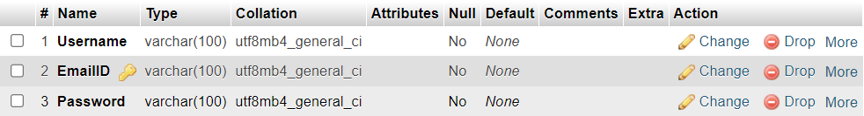

* **USER TABLE:**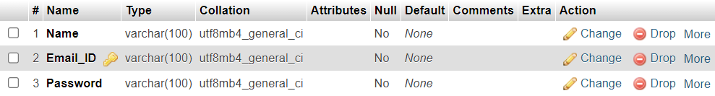
* **USER DATA:**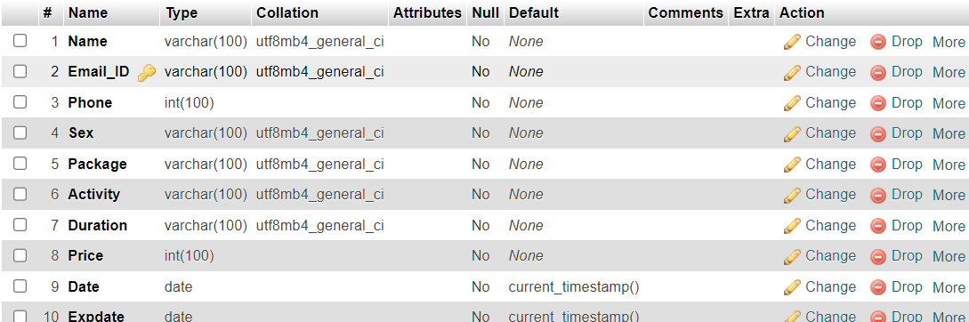

1. **USER INTERFACE DESIGN:**
2. **HOME PAGE DESIGN:**

The home page of the APEXFLEX gym website is designed to be the first touchpoint for users, providing a visually striking and engaging introduction to the gym's brand and offerings.

1. **HERO SECTION:**

The hero section, prominently featured at the top of the home page, showcases high-quality imagery of the gym's state-of-the-art facilities and equipment. This section also includes a concise tagline and a brief description that highlights the gym's unique value.

1. **FEATURED SERVICE:**

Below the hero section, the home page features a grid of icons or images representing the gym's key services, such as STRENGTH TRAINING, CARDIO TRAINING, FAT BURNING and HEALTH FITNESS. Each service is accompanied by a brief description and a call-to-action button that directs users to the corresponding service page.

1. **MEMBERSHIP PRICING:**

The home page also includes a clear and concise overview of the gym's membership plans, including pricing, benefits, and any ongoing promotions or special offers. This section aims to provide users with a quick understanding of the available membership options and encourage them to explore the membership page for more details.

1. **MEMBER DASHBOARD DESIGN:**

The member dashboard is a crucial component of the APEXFLEX gym website, providing a personalized and intuitive interface for members to manage their accounts.

**CODING**

**CODING APPROACH: TOP-DOWN**

The APEXFLEX gym website project utilized a top-down coding approach to ensure a well-structured and scalable codebase. This approach involves starting with the high-level design and gradually breaking down the system into smaller, more manageable components.

By adopting a top-down coding approach, the APEXFLEX gym website project team was able to create a well-structured and scalable codebase that can easily accommodate future updates and enhancements. This approach also facilitated efficient resource allocation and enabled the team to deliver a high-quality website that meets the gym's needs and exceeds member expectations.

**TESTING**

**TEST CASES AND TEST CRITERIA**

The APEXFLEX gym website project has undergone a comprehensive testing process to ensure the quality, functionality, and reliability of the application. The following test cases and test criteria were defined and executed:

**MEMBER MANAGEMENT TESTS**

**TEST CASE 1: SUCCESSFUL MEMBER REGISTRATION**

**OBJECTIVE:** Verify that a new member can successfully register on the website.

**STEPS:**

* Navigate to the member registration page(Contact us).
* Enter valid user data (name, email, phone etc).
* Click the "Submit" button.

**EXPECTED RESULT:** A new member record is created in the database, and the user is redirected to the login page.

**TEST CASE 2: INVALID MEMBER REGISTRATION**

**OBJECTIVE:** Verify that the system handles invalid user data during the registration process.

**STEPS:**

* Navigate to the member registration page(Contact us).
* Enter invalid user data (e.g., wrong username, wrong email etc).
* Click the "login" button.

**EXPECTED RESULT:** The system displays an error message, and the registration process is not completed.

**TEST CASE 3: SUCCESSFUL MEMBER LOGIN**

**OBJECTIVE:** Verify that a registered member can successfully log in to the website.

**STEPS:**

* Navigate to the member login page.
* Enter valid email and password credentials.
* Click the "Login" button.

**EXPECTED RESULT:** The user is authenticated and redirected to the member dashboard.

**TEST CASE 4: INVALID MEMBER LOGIN**

**OBJECTIVE:** Verify that the system handles invalid login credentials.

**STEPS:**

* Navigate to the member login page.
* Enter an invalid email address or password.
* Click the "Login" button.

**EXPECTED RESULT:** The system displays an error message indicating that the login credentials are invalid, and the user is not authenticated.

**CLASS SCHEDULING TESTS**

**TEST CASE 5: CREATE A WORKOUT PLAN**

**OBJECTIVE:** Verify that the workout plan for individual members can successfully created.

**STEPS:**

* Navigate to the "Contact us" section of the website.
* Fill the various details of the form (e.g., fitness package, activity, date and duration ).
* Click the "Submit" button to finish the booking process.

Expected Result: The workout plan is created accordingly.

**TEST CASE 6:** **VIEW THE WORKOUT PLAN**

**OBJECTIVE:** Verify that users can view the workout plan.

**STEPS:**

* Navigate to the "Workout" section of the user webpage.
* Verify that the displayed class sessions match to the the information filled.

**EXPECTED RESULT:** The class schedule is displayed correctly.

**TEST CASE 7: RENEW THE WORKOUT PLAN**

**OBJECTIVE:** Verify that the workout plan for individual members can successfully created.

**STEPS:**

* Navigate to the "Renew" section of the user webpage.
* Fill the various details of the form (e.g., fitness package, activity, date and duration ).
* Click the "Submit" button to finish the renew process.

**EXPECTED RESULT:** The workout plan is renewed accordingly.

**BMI CALCULATOR TEST**

**TEST 8: BMI CALCULATOR WORKS PROPERLY**

**OBJECTIVE:** Verify that calculation works properly**.**

**STEPS:**

* Navigate to the "BMI" section of the user webpage.
* Fill the various details (e.g.,height and weight).
* Click the "Calculate" button to calculate the BMI.

**EXPECTED RESULT:** It will print your BMI ,fitness range and some workout plan suggestions.

**IMPLEMENTATION**

Once the system was tested (module wise as well as integrated) satisfactorily, and then

comes the implementation of the system. Implementation is the process of changing from old system (manual) to the new system (computerized). Some training was also given to the user about how to work on the new system and finally the system was successfully adopted.

**EVALUATION OF PROJECT**

The evaluation of the APEXFEX gym website project would involve assessing the following key aspects:

* + Functional Correctness: Verify that all the website's features and functionalities are working as expected, without any bugs or errors.
  + Usability and User Experience: Assess the website's user-friendliness, navigation, and overall interaction flow through usability testing from APEXFLEX members.
  + Security and Data Integrity: Evaluate the website's security measures, including user authentication, authorization, and data protection, to ensure the confidentiality and integrity of member information.
  + Performance and Scalability: Assess the website's performance under various load conditions, including page load times, response times, and the ability to handle increasing user traffic.
  + Integration with Gym Management Software: Verify the seamless integration between the website and the gym's management software, ensuring data synchronization and a cohesive user experience.
  + Content Management and Maintainability: Evaluate the effectiveness of the content management system, including the APEXFLEX's ability to update and manage the website's content.
  + Overall Project Success: Assess the project's overall success in meeting the initial requirements, stakeholder expectations, and the APEXFLEX objectives.

**CODE DETAILS**

**APEXFLEX.PHP**

<?php session_start(); ?>

<!DOCTYPE html>

<html lang="en">

<head>

<meta charset="UTF-8">

<meta name="viewport" content="width=device-width, initial-scale=1.0">

<link rel="stylesheet" href="APEXFLEX.css">

<title>APEXFLEX</title>

<script>

function calculateEndDate() {

var joinDate = document.getElementById("join_date").value;

var durationValue = document.getElementById("duration_value").value;

var durationType = document.getElementById("duration_type").value;

var endDate = new Date(joinDate);

if (durationType === "month") {

endDate.setMonth(endDate.getMonth() + parseInt(durationValue));

} else if (durationType === "year") {

endDate.setFullYear(endDate.getFullYear() + parseInt(durationValue));

}

var endDateString = endDate.toISOString().split("T")[0];

document.getElementById("end_date").value = endDateString;}

</script>

</head>

<body>

<header>

<a name="web1"></a>

<div class="web1">

<video src="mixkit-woman-and-man-doing-dumbbell-reps-together-44413.mp4" autoplay muted loop class="v1"></video>

<div class="para">

<h1>WELCOME TO APEXFLEX</h1>

<a href="#web5" id="b1">Book Now</a>

</div>

</header>

<section>

<div class="web2">

<a name="web2"></a>

<div class="p1">

<h1>ABOUT APEXFLEX</h1>

<p>APEXFLEX is a community of fitness enthusiasts, professionals, and beginners alike. Our dedicated team of certified trainers and staff are passionate about helping you unlock your full potential and transform your body and mind.</p>

<h1>OUR MISSION</h1>

<p>we are committed to empowering individuals to achieve their fitness goals and lead a healthier, more active lifestyle. Our mission is to create a positive and motivating environment where everyone, regardless of their fitness level, feels welcome and inspired to reach new heights.</p>

</div>

<img src="gym1.jpg" alt="image">

</div>

</section>

<section>

<div class="web3">

<a name="web3"></a>

<video src="mixkit-muscular-woman-and-man-stretching-in-a-gym-44440.mp4" autoplay muted loop class="v1"></video>

<div class="web3">

<div class="c3">

<h1>EXPLORE OUR PROGRAMS</h1>

</div>

<div id="act">

<h2>STRENGTH TRAINING</h2>

<p>In this program, you are trained to improve your strength through many exercises.</p></div>

<div id="act">

<h2>CARDIO TRAINING</h2>

<p>In this program, you are trained to do sequential moves in range of 20 until 30 minutes.</p>

</div>

<div id="act">

<h2>FAT BURNING</h2>

<p>This program is suitable for you who wants to get rid of your fat and lose their weight.</p>

</div>

<div id="act">

<h2>HEALTH FITNESS</h2>

<p>This programs is designed for those who exercises only for their body fitness not body building.</p>

</div>

</div>

</section>

</div>

</div>

</section>

<section>

<div class="web4">

<a name="web4"></a>

<div id="tbox">

<div id="c">

<h1>FITNESS PACKAGES</h1>

<p>We have prepared monthly and annual memberships of each activity to feed your individual needs. Our pricing is competitive and quite affordable. Check our plans and hurry up to join us! </p>

<a href="monthlypackage.php" id="b3">MONTHLY MEMBERSHIPS ></a>

<a href="annualpackage.php"id="b3">ANNUAL MEMBERSHIPS ></a>

</div>

</div>

</div>

</section>

<section>

<div class="web5">

<a name="web5">

<video src="mixkit-woman-and-man-doing-squats-together-in-a-gym-44438.mp4" autoplay muted loop class="v2"></video>

<h1>We Are here To Help You! To Shape Your Body.</h1>

<form method="post" action="connection.php">

<h3>Leave Your Information Here</h3>

<input type="text" placeholder="Name *" name="name" class="ip">

<input type="text" placeholder="EmailID *" name="email" class="ip">

<input type="text" placeholder="Phone Number *" name="phoneno" class="ip">

<select name="sex" id="gender">

<option value="Male"disabled selected hidden>Gender</option>

<option value="Male">Male</option>

<option value="Female">Female</option>

</select>

<select name="package" id="sel">

<option value=""disabled selected hidden>Membership</option>

<option value="Beginner Membership">Beginner</option>

<option value="Intermediate Membership">Intermediate</option>

<option value="Pro Membership">Pro</option>

</select>

<select name="activity" id="sel" >

<option value=""disabled selected hidden>Activity</option>

<option value="Strength Training">Strength Training</option>

<option value="Cardio Training">Cardio Training</option>

<option value="Fat Burning">Fat Burning</option>

<option value="Health Fitness">Health Fitness</option>

</select>

<input type="number" placeholder="Duration" name="d1" id="duration_value" onchange="calculateEndDate()">

<select id="duration_type" name="d2" onchange="calculateEndDate()">

<option value="month">Months</option>

<option value="year">Years</option>

</select>

<input type="date" placeholder="Joining Date" name="date" id="join_date" onchange="calculateEndDate()">

<input type="text" id="end_date" placeholder="End Date" name="expdate" readonly>

<input type="submit" value="Submit" id="submit">

</form>

</div>

</section>

<footer>

<?php

include("nav.php");

?>

<button id="b6"><a href="#web1">^</a></button>

</footer>

</body>

</html>

**NAV.PHP**

<!DOCTYPE html>

<html lang="en">

<head>

<meta charset="UTF-8">

<meta name="viewport" content="width=device-width, initial-scale=1.0">

<title>Nav Bar</title>

</head>

<body>

<header>

<nav>

<a href="APEXFLEX.php#web1" >

<img src="f718fd1dc9fa4867927556147970c72d__1_-removebg-preview.png" alt="logo" id="logo"></a>

</nav>

<nav id="menu">

<a href="APEXFLEX.php#web2">About us</a>

<a href="APEXFLEX.php#web3">Activities</a>

<a href="APEXFLEX.php#web4">Fitness packages</a>

<a href="APEXFLEX.php#web5">Contact us</a>

</nav>

<nav id="signup">

<button id="su"><img src="th-removebg-preview.png" alt="user"><a href="login.php">Log In</a></button>

</nav>

</header>

</body>

</html>

**ANNUALPACKAGE.PHP**

<html>

<head>

<title>Annual Packages</title>

</head>

<body>

<video src="mixkit-portrait-of-young-athletes-in-the-gym-40247 (2).mp4" autoplay muted loop></video>

<header>

<?php

include("nav.php");

?>

</header>

<div class="ap">

<a name="ap"></a>

<div class="c4">

<h1>ANNUAL MEMBERSHIPS</h1>

<p>Choose one of the annual plans that suits you goals the most</p>

</div>

<div id="box1">

<ul>

<li><h3>Beginner Training</h3></li>

<li id="rs">Rs 15,000</li>

<li>Per year</li>

<li>1hr Per Day</li>

<li>365 classes</li>

<li>Workout Plan</li>

<li><a href="APEXFLEX.php#web5" id="b4">Become a member</a></li>

</ul>

</div>

<div id="box1">

<ul>

<li><h3>Intermediate Training</h3></li>

<li id="rs">Rs 17,000</li>

<li>Per year</li>

<li>1hr 30mins Per Day</li>

<li>365 classes</li>

<li>Workout Plan</li>

<li><a href="APEXFLEX.php#web5" id="b4">Become a member</a></li>

</ul>

</div>

<div id="box1">

<ul>

<li><h3>Pro Training</h3></li>

<li id="rs">Rs 20,000</li>

<li>Per year</li>

<li>2hr Per Day</li>

<li>365 classes</li>

<li>Workout Plan</li>

<li><a href="APEXFLEX.php#web5" id="b4">Become a member</a></li>

</ul>

</div>

</body>

</html>

**MONTHLYPACKAGE.PHP**

<html>

<head></head>

<title>Monthly Packages</title>

</head>

<body>

<video src="mixkit-portrait-of-young-athletes-in-the-gym-40247 (2).mp4" autoplay muted loop></video>

<header>

<?php

include("nav.php");

?>

</header>

<div class="container">

<div class="mp">

<a name="mp"></a>

<div class="c4">

<h1>MONTHLY MEMBERSHIPS</h1>

<p>Choose one of the monthly plans that suits you goals the most.</p>

</div>

<div id="box1">

<ul>

<li><h3>Beginner Training</h3></li>

<li id="rs">Rs 1,400</li>

<li>Per Month</li>

<li>1hr Per Day</li>

<li>28 classes</li>

<li>Workout Plan</li>

<li><a href="APEXFLEX.php#web5" id="b4">Become a member</a></li>

</ul>

</div>

<div id="box1">

<ul>

<li><h3>Intermediate Training</h3></li>

<li id="rs">Rs 1,600</li>

<li>Per Month</li>

<li>1hr 30mins Per Day</li>

<li>28 classes</li>

<li>Workout Plan</li>

<li><a href="APEXFLEX.php#web5" id="b4">Become a member</a></li>

</ul>

</div>

<div id="box1">

<ul>

<li><h3>Pro Training</h3></li>

<li id="rs">Rs 2,000</li>

<li>Per Month</li>

<li>2hr Per Day</li>

<li>28 classes</li>

<li>Workout Plan</li>

<li><a href="APEXFLEX.php#web5" id="b4">Become a member</a></li>

</ul>

</div>

</body>

</html>

**DATABASE.PHP**

<?php

$db_server="localhost";

$db_user="root";

$db_pass="";

$db_name="APEXFLEX";

$con=mysqli_connect($db_server,$db_user,$db_pass,$db_name);

?>

**CONNECTION.PHP**

<?php

session_start();

include("database.php");

if ($_SERVER["REQUEST_METHOD"] == "POST") {

$name=$_REQUEST["name"];

$email=$_REQUEST["email"];

$phoneno=$_REQUEST["phoneno"];

$sex=$_REQUEST["sex"];

$package=$_REQUEST["package"];

$activity=$_REQUEST["activity"];

$expdate=$_REQUEST["expdate"];

$date=$_REQUEST["date"];

$duration1=$_REQUEST["d1"];

$duration2=$_REQUEST["d2"];

$duration=$duration1." ".$duration2;

if($duration2=="month"){

if($package=="Beginner Membership"){

$price=1400*$duration1;

}

elseif($package=="Intermediate Membership"){

$price=1600*$duration1;

}

elseif($package=="Pro Membership"){

$price=2000*$duration1;

}

else{

$price=0;

}

}

if($duration2=="year"){

if($package=="Beginner Membership"){

$price=15000*$duration1;

}

elseif($package=="Intermediate Membership"){

$price=17000*$duration1;

}

elseif($package=="Pro Membership"){

$price=20000*$duration1;

}

else{

$price=0;

}

}

if(empty($name)){ echo"Please enter your Name";}

elseif(empty($email)){ echo"Please enter your Email";}

elseif(empty($phoneno)){ echo"Please enter your Phone Number";}

elseif(empty($package)){ echo"Please select your Package";}

else{

$stmt = $con->prepare("INSERT INTO data(Name, Email_Id, Phone, Sex, Package,Activity,Duration,Price, Date, Expdate) VALUES( ?, ?, ?, ?, ?, ?, ?, ?, ?, ?)");

$stmt->bind_param("ssissssiss", $name, $email, $phoneno, $sex, $package,$activity,$duration,$price,$date,$expdate);

$execval = $stmt->execute();

$stmt->close();

$_SESSION['name']=$name;

$_SESSION['email']=$email;

$_SESSION['phone']=$phoneno;

$_SESSION['package']=$package;

$_SESSION['expdate']=$expdate;

$_SESSION['date']=$date;

header("Location: signup.php");}}

mysqli_close($con);

?>

**SIGNUP.PHP**

<?php

session_start();

include("database.php");

?>

<!DOCTYPE html>

<html lang="en">

<body>

<video src="mixkit-athletic-couple-in-functional-training-40241.mp4"autoplay muted loop class="back-video"></video>

<form method="post">

<h3>Sign up Here</h3>

<label for="username">Enter Username</label>

<input type="text" placeholder="Username" value="<?php if(isset($_SESSION['name'])){echo $_SESSION['name'];}?>" id="username" name="username"required>

<label for="username">Enter Email</label>

<input type="text" placeholder="Email" value="<?php if(isset($_SESSION['email'])){echo $_SESSION['email'];}?>" id="username" name="emailid"required>

<label for="password">Create Password</label>

<input type="password" placeholder="Password" id="password" name="password" required>

<h5>Already have an account? <a href="userlogin.php">Login Here</a> </h5>

<input type="submit" value="SignUp" name="signup" id="su">

</body>

</html>

<?php

include("database.php");

if ($_SERVER["REQUEST_METHOD"] == "POST"){

$username=$_POST['username'];

$email=$_POST['emailid'];

$password=$_POST["password"];

if(isset($_POST["signup"])){

if(empty($username)){ echo "Please Enter Your Username";}

elseif(empty($email)){ echo "Please Enter Your Email";}

elseif(empty($password)){ echo "Please Enter Your Password </form>";}

else{

$stmt = $con->prepare("INSERT INTO userinfo( Name, Email_ID,Password) VALUES(?, ?, ?)");

$stmt->bind_param("sss", $username,$email, $password);

$execval = $stmt->execute();

$stmt->close();

header("Location: userlogin.php");}}}

mysqli_close($con);

session_unset();

?>

**LOGIN.PHP**

<!DOCTYPE html>

<html lang="en">

<head>

<meta charset="UTF-8">

<meta name="viewport" content="width=device-width, initial-scale=1.0">

<title>Login</title>

</head>

<body>

<video src="mixkit-athletic-couple-in-functional-training-40241.mp4"autoplay muted loop class="back-video"></video>

<header>

<?php

include("nav.php");

?>

</header>

<div class="web">

<h2>LOGIN AS</h2>

<a href="adminlogin.php" id="b">ADMIN</a>

<a href="userlogin.php"id="b">USER</a>

</div>

</body>

</html>

**LOGOUT.PHP**

<?php

session_start();

session_unset();

session_destroy(); // function that Destroys Session

header("Location: login.php");

echo "Logout Successfully ";

?>

**ADMINLOGIN.PHP**

<?php

session_start();

?>

<!DOCTYPE html>

<html lang="en">

<head>

<title>Admin Login</title>

</head>

<body>

<video src="mixkit-athletic-couple-in-functional-training-40241.mp4"autoplay muted loop class="back-video"></video>

<form method="post" >

<h3>Login Here</h3>

<label for="username">Email</label>

<input type="text" placeholder="Enter Your Email" name="username" id="username" required>

<label for="password">Password</label>

<input type="password" placeholder="Enter Your Password" name="password" id="password" required>

<input type="submit" value="Log In" name="login" id="su" >

</form>

</body>

</html>

<?php

include("database.php");

function test_input($data) {

$data = trim($data);

$data = stripslashes($data);

$data = htmlspecialchars($data);

return $data;

}

if ($con -> connect_errno) {

echo "Failed to connect to MySQL: " . $con -> connect_error;

exit();

}

else{

if(isset($_POST['login'])){

if ($_SERVER["REQUEST_METHOD"] == "POST") {

$username = test_input($_POST["username"]);

$password = test_input($_POST["password"]);

$sql = ("SELECT * FROM admininfo");

if($sql){

$users = $con -> query($sql);

// Fetch all

$users -> fetch_all();

foreach($users as $user) {

if($username!==$user['EmailID'])

{echo'Wrong Username </form>'; }

elseif(($password!==$user['Password'])) {echo'Wrong Password </form>';}

else{

$_SESSION['username']=$user['Username'];

header("Location: admin.php");

}

break;

} }}}

mysqli_close($con);

?>

**ADMIN.PHP**

<?php

session_start();

include("database.php");

?>

<!DOCTYPE html>

<html lang="en">

<head>

<meta charset="UTF-8">

<meta name="viewport" content="width=device-width, initial-scale=1.0">

<title>Admin</title>

</head>

<body>

<header>

<nav>

<a href="APEXFLEX.php#web1" >

<img src="f718fd1dc9fa4867927556147970c72d__1_-removebg-preview.png" alt="logo" id="logo"></a>

</nav>

<nav id="signup">

<a href="logout.php" id="su">Logout</a><img src="th-removebg-preview.png" alt="user" id="img">

</nav>

</header>

<div class="web">

<h1 id="wel">Welcome

<?php

echo"{$_SESSION['username']}";

?> </h1>

<div class="tablewrap">

<table class="table ">

<thead><tr>

<th> NAME</th>

<th>EMAILID</th>

<th>PHONE NUMBER</th>

<th>SEX</th>

<th>PACKAGE</th>

<th>ACTIVITY</th>

<th>DURATION</th>

<th>JOINING DATE</th>

<th>EXP DATE</th>

<th>PRICE</th>

</thead>

<tbody>

<?php

$sql = ("SELECT * FROM data");

$users = $con -> query($sql);

// Fetch all

$users -> fetch_all();

foreach($users as $user){

?>

<tr>

<td><?php echo"{$user['Name']}";?></td>

<td><?php echo"{$user['Email_ID']}";?></td>

<td><?php echo"{$user['Phone']}";?></td>

<td><?php echo"{$user['Sex']}";?></td>

<td><?php echo"{$user['Package']}";?></td>

<td><?php echo"{$user['Activity']}";?></td>

<td><?php echo"{$user['Duration']}";?></td>

<td><?php echo"{$user['Date']}";?></td>

<td><?php echo"{$user['Expdate']}";?></td>

<td><?php echo"{$user['Price']}"?></td>

<?php

}

?>

</tr>

</tbody>

</table>

</div>

</div>

</body>

</html>

<?php

mysqli_close($con);

?>

**USERLOGIN.PHP**

<?php

session_start();

?>

<!DOCTYPE html>

<html lang="en">

<head>

<title>User Login</title>

</head>

<body>

<video src="mixkit-athletic-couple-in-functional-training-40241.mp4"autoplay muted loop class="back-video"></video>

<form method="post" >

<h3>Login Here</h3>

<label for="username">Email</label>

<input type="text" placeholder="Enter Your Email" name="username" id="username" required>

<label for="password">Password</label>

<input type="password" placeholder="Enter Your Password" name="password" id="password" required>

<h5>Not a Member? <a href="signup.php">SignUp now</a> </h5>

<input type="submit" value="Log In" name="login" id="su" >

</form>

</body>

</html>

<?php

include("database.php");

function test_input($data) {

$data = trim($data);

$data = stripslashes($data);

$data = htmlspecialchars($data);

return $data;

}

if ($con -> connect_errno) {

echo "Failed to connect to MySQL: " . $con -> connect_error;

exit();

}

else{

if(isset($_POST['login'])){

if ($_SERVER["REQUEST_METHOD"] == "POST") {

$username = test_input($_POST["username"]);

$password = test_input($_POST["password"]);

$sql = ("SELECT * FROM userinfo");

if($sql){

$users = $con -> query($sql);

// Fetch all

$users -> fetch_all();

foreach($users as $user) {

if($username!==$user['Email_ID'])

{echo'Wrong Username </form>';}

elseif(($password!==$user['Password'])) { echo'Wrong Password </form>'; }

else{

$_SESSION['Name']=$user['Name'];

$_SESSION['Email']=$user['Email_ID'];

header("Location: user.php");

}}}}}}

mysqli_close($con);

?>

**USER.PHP**

<?php

session_start();

include("database.php");

?>

<!DOCTYPE html>

<html lang="en">

<head>

<meta charset="UTF-8">

<meta name="viewport" content="width=device-width, initial-scale=1.0">

<title>User</title>

</head>

<body>

<video src="mixkit-portrait-of-young-athletes-in-the-gym-40247 (2).mp4" autoplay muted loop></video>

<header>

<nav>

<a href="user.php" >

<img src="f718fd1dc9fa4867927556147970c72d__1_-removebg-preview.png" alt="logo" id="logo"></a>

</nav>

<nav id="menu">

<a href="bmi.php">BMI calculator</a>

<a href="userinfo.php">Personal info</a>

<a href="workoutplan.php">Workout Plan</a>

<a href="repack.php">Renew packages</a>

</nav>

<nav id="signup">

<a href="logout.php" id="su">Logout</a><img src="th-removebg-preview.png" alt="user" id="img">

</nav>

</header>

<div class="web">

<h1 id="wel">Welcome

<?php

$name=$_SESSION['Name'];

echo"{$name} To APEXFLEX";

?>

</h1>

<div class="info">

</div>

</div>

</body>

</html>

**USERINFO.PHP**

<!DOCTYPE html>

<html lang="en">

<head>

<meta charset="UTF-8">

<meta name="viewport" content="width=device-width, initial-scale=1.0">

<title>User Information </title>

</head>

<body>

<video src="mixkit-portrait-of-young-athletes-in-the-gym-40247 (2).mp4" autoplay muted loop></video>

<header>

<nav>

<a href="user.php" >

<img src="f718fd1dc9fa4867927556147970c72d__1_-removebg-preview.png" alt="logo" id="logo"></a>

</nav>

<nav id="menu">

<a href="bmi.php">BMI calculator</a>

<a href="userinfo.php">Personal info</a>

<a href="workoutplan.php">Workout Plan</a>

<a href="repack.php">Renew packages</a>

</nav>

<nav id="signup">

<a href="logout.php" id="su">Logout</a><img src="th-removebg-preview.png" alt="user" id="img">

</nav>

</header>

<?php

session_start();

include("database.php");

$sql = "SELECT * FROM data WHERE Name='{$_SESSION['Name']}'";

$result = $con->query($sql);

if ($result->num_rows > 0) {

// output data of each row

while($row = $result->fetch_assoc()) {

echo "<p class=\"info\"><br> Your EmailID: ". $row["Email_ID"];

echo " <br>Phone Number: ". $row["Phone"];

echo " <br>Gender: ". $row["Sex"];

echo " <br>Package: ". $row["Package"];

echo " <br>Activity: ". $row["Activity"];

echo " <br>Price: ". $row["Price"];

echo " <br>Duration: ". $row["Date"]." To ".$row["Expdate"]." (".$row["Duration"].")</p>";

$_SESSION['Email']=$row["Email_ID"];

}

} else {

echo "0 results";

}

?>

</body>

</html>

**BMI.PHP**

<!DOCTYPE html>

<html lang="en">

<head>

<meta charset="UTF-8">

<meta name="viewport" content="width=device-width, initial-scale=1.0">

<title>BMI Calculator</title>

</head>

<body>

<video src="mixkit-portrait-of-young-athletes-in-the-gym-40247 (2).mp4"autoplay muted loop></video>

<header>

<nav>

<a href="user.php" >

<img src="f718fd1dc9fa4867927556147970c72d__1_-removebg-preview.png" alt="logo" id="logo"></a>

</nav>

<nav id="menu">

<a href="bmi.php">BMI calculator</a>

<a href="userinfo.php">Personal info</a>

<a href="workoutplan.php">Workout Plan</a>

<a href="repack.php">Renew packages</a>

</nav>

<nav id="signup">

<a href="logout.php" id="su">Logout</a><img src="th-removebg-preview.png" alt="user" id="img">

</nav>

</header>

<div class="container">

<h1>CALCULATE YOUR BMI HERE</h1>

<p>The Body Mass Index(BMI) calculator calculates body mass index from your weight and height.</p>

<form method="post" action="<?php echo htmlspecialchars($_SERVER["PHP_SELF"]);?>">

<label for="height" id="cil">Height (cm):</label>

<input type="number" name="height" step="0.1" id="cip">

<label for="height" id="cil"> Weight (kg):</label>

<input type="number" name="weight" step="0.1"id="cip" required>

<input type="submit" name="submit" id="submit" value="Calculate">

</form>

<?php

if ($_SERVER["REQUEST_METHOD"] == "POST") {

$height = $_POST["height"];

$weight = $_POST["weight"];

$bmi = $weight / (($height/100) * ($height/100));

$bmi = round($bmi, 1);

echo "<h2>Your BMI is: $bmi</h2>";

if ($bmi < 18.5) {

echo "You are underweight.<br>";

echo "Strength Training is Suggested ";

} elseif ($bmi >= 18.5 && $bmi <= 24.9) {

echo "You are in the healthy weight range.";

echo "Strength Training,Cardio Training are Suggested ";

} elseif ($bmi >= 25 && $bmi <= 29.9) {

echo "You are overweight.";

echo "Strength Training,Cardio Training,Fat Burning are Suggested ";

} else {

echo "You are obese.";

echo "Strength Training,Cardio Training,Fat Burning are Suggested ";

}

}

?>

</div>

</body>

</html>

**WOROUTPLAN.PHP**

<?php

session_start();

include('database.php')

?>

<!DOCTYPE html>

<html lang="en">

<head>

<meta charset="UTF-8">

<meta name="viewport" content="width=device-width, initial-scale=1.0">

<title>Document</title>

</head>

<body>

<video src="mixkit-portrait-of-young-athletes-in-the-gym-40247 (2).mp4" autoplay muted loop></video>

<header>

<nav>

<a href="user.php" >

<img src="f718fd1dc9fa4867927556147970c72d__1_-removebg-preview.png" alt="logo" id="logo"></a>

</nav>

<nav id="menu">

<a href="bmi.php">BMI calculator</a>

<a href="userinfo.php">Personal info</a>

<a href="workoutplan.php">Workout Plan</a>

<a href="repack.php">Renew packages</a>

</nav>

<nav id="signup">

<a href="logout.php" id="su">Logout</a><img src="th-removebg-preview.png" alt="user" id="img">

</nav>

</header>

<?php

// Define the weekly plans for different fitness levels

$plans = array(

'Beginner Membership' => array(

'Cardio Training' => array(

1 => array(

'Monday' => 'Treadmill - 30 minutes',

'Tuesday' => 'Cycling - 30 minutes',

'Wednesday' => 'Rope Skipping- 30 minutes',

'Thursday' => 'Cycling - 30 minutes',

'Friday' => 'Treadmill - 30 minutes',

'Saturday' => 'Rope Skipping- 30 minutes',

'Sunday' => 'Rest Day'

),

2 => array(

'Monday' => 'Cycling - 30 minutes',

'Tuesday' => 'Treadmill - 30 minutes',

'Wednesday' =>'Rope Skipping- 30 minutes',

'Thursday' => 'Treadmill - 30 minutes',

'Friday' => 'Cycling - 30 minutes',

'Saturday' => 'Rope Skipping- 30 minutes',

'Sunday' => 'Rest Day'

),

3 => array(

'Monday' =>'Cycling - 30 minutes',

'Tuesday' => 'Treadmill - 30 minutes',

'Wednesday' => 'Rope Skipping- 30 minutes',

'Thursday' => 'Cycling - 30 minutes',

'Friday' => 'Treadmill - 30 minutes',

'Saturday' => 'Rope Skipping- 30 minutes',

'Sunday' => 'Rest Day'

),

4 => array(

'Monday' => 'Treadmill - 30 minutes',

'Tuesday' => 'Cycling - 30 minutes',

'Wednesday' => 'Rope Skipping- 30 minutes',

'Thursday' => 'Cycling - 30 minutes',

'Friday' => 'Treadmill - 30 minutes',

'Saturday' => 'Rope Skipping- 30 minutes',

'Sunday' => 'Rest Day'

)

),

'Strength Training' => array(

1 => array(

"Monday" => "Bench Press (2x10-12), Overhead Press (2x8-10), Barbell Rows (2x10-12)",

"Tuesday" => "Squats (2x10-12), Deadlifts (2x6-8)",

"Wednesday" => "Rest",

"Thursday" => "Bench Press (2x10-12), Overhead Press (2x8-10), Barbell Rows (2x10-12)",

"Friday" => "Squats (2x10-12), Deadlifts (2x6-8)",

"Saturday" => "Rest",

"Sunday" => "Rest"

),

2 => array(

"Monday" => "Squats (2x10-12), Lunges (2x12-15 per leg), Calf Raises (2x15-20)",

"Tuesday" => "Bench Press (2x10-12), Dumbbell Flyes (2x12-15), Tricep Extensions (2x12-15)",

"Wednesday" => "Rest",

"Thursday" => "Deadlifts (2x6-8), Rows (2x10-12), Shrugs (2x12-15)",

"Friday" => "Overhead Press (2x8-10), Lateral Raises (2x12-15), Front Raises (2x12-15)",

"Saturday" => "Rest",

"Sunday" => "Rest"

),

3 => array(

"Monday" => "Bench Press (2x10-12), Incline Bench Press (2x10-12), Dumbbell Pullovers (2x12-15)",

"Tuesday" => "Squats (2x10-12), Leg Press (2x12-15), Leg Extensions (2x12-15)",

"Wednesday" => "Rest",

"Thursday" => "Deadlifts (2x6-8), Barbell Rows (2x10-12), Chin-ups (2x6-8)",

"Friday" => "Overhead Press (2x8-10), Arnold Press (2x12-15), Lateral Raises (2x12-15)",

"Saturday" => "Rest",

"Sunday" => "Rest"

),

4 => array(

"Monday" => "Squats (2x10-12), Lunges (2x12-15 per leg), Calf Raises (2x15-20)",

"Tuesday" => "Bench Press (2x10-12), Dumbbell Flyes (2x12-15), Tricep Extensions (2x12-15)",

"Wednesday" => "Rest",

"Thursday" => "Deadlifts (2x6-8), Bent-over Rows (2x10-12), Shrugs (2x12-15)",

"Friday" => "Overhead Press (2x8-10), Lateral Raises (2x12-15), Front Raises (2x12-15)",

"Saturday" => "Rest",

"Sunday" => "Rest"

)

),

'Fat Burning' => array(

1 => array(

'Monday' => 'Interval Training - 30 minutes',

'Tuesday' => 'Treadmill - 30 minutes',

'Wednesday' => 'Rest Day',

'Thursday' => 'Cycling - 30 minutes',

'Friday' => 'Bodyweight Exercises - 30 minutes',

'Saturday' => 'Jogging - 30 minutes',

'Sunday' => 'Rest Day'

),

2 => array(

'Monday' => 'Interval Training - 30 minutes',

'Tuesday' => 'Treadmill - 30 minutes',

'Wednesday' => 'Rest Day',

'Thursday' => 'Cycling - 30 minutes',

'Friday' => 'Bodyweight Exercises - 30 minutes',

'Saturday' => 'Jogging - 30 minutes',

'Sunday' => 'Rest Day'

),

3 => array(

'Monday' => 'Interval Training - 30 minutes',

'Tuesday' => 'Treadmill - 30 minutes',

'Wednesday' => 'Rest Day',

'Thursday' => 'Cycling - 30 minutes',

'Friday' => 'Bodyweight Exercises - 30 minutes',

'Saturday' => 'Jogging - 30 minutes',

'Sunday' => 'Rest Day'

),

4 => array(

'Monday' => 'Interval Training - 30 minutes',

'Tuesday' => 'Treadmill - 30 minutes',

'Wednesday' => 'Rest Day',

'Thursday' => 'Cycling - 30 minutes',

'Friday' => 'Bodyweight Exercises - 30 minutes',

'Saturday' => 'Jogging - 30 minutes',

'Sunday' => 'Rest Day'

),

),

'Health Fitness' => array(

1 => array(

'Monday' => 'Treadmill - 30 minutes',

'Tuesday' => 'Bodyweight Exercises - 30 minutes',

'Wednesday' => 'Rest Day',

'Thursday' => 'Cycling - 30 minutes',

'Friday' => 'Yoga - 30 minutes',

'Saturday' => 'Bodyweight Exercises - 30 minutes',

'Sunday' => 'Rest Day'

),

2 => array(

'Monday' => 'Bodyweight Exercises - 30 minutes',

'Tuesday' => 'Yoga - 30 minutes',

'Wednesday' => 'Rest Day',

'Thursday' =>'Bodyweight Exercises - 30 minutes',

'Friday' => 'Yoga - 30 minutes',

'Saturday' => 'Bodyweight Exercises - 30 minutes',

'Sunday' => 'Rest Day'

),

3 => array(

'Monday' => 'Treadmill - 30 minutes',

'Tuesday' => 'Bodyweight Exercises - 30 minutes',

'Wednesday' => 'Rest Day',

'Thursday' => 'Cycling - 30 minutes',

'Friday' => 'Yoga - 30 minutes',

'Saturday' => 'Treadmill - 30 minutes',

'Sunday' => 'Rest Day'

),

4 => array(

'Monday' => 'Bodyweight Exercises - 30 minutes',

'Tuesday' => 'Yoga - 30 minutes',

'Wednesday' => 'Rest Day',

'Thursday' =>'Bodyweight Exercises - 30 minutes',

'Friday' => 'Yoga - 30 minutes',

'Saturday' => 'Treadmill - 30 minutes',

'Sunday' => 'Rest Day'

),

),)

,

'Intermediate Membership' => array(

'Cardio Training' => array(

1 => array(

'Monday' => 'Treadmill - 45 minutes',

'Tuesday' => 'Cycling - 45 minutes',

'Wednesday' => 'Rope Skipping- 45 minutes',

'Thursday' => 'Cycling - 45 minutes',

'Friday' => 'Treadmill - 45 minutes',

'Saturday' => 'Rope Skipping- 45 minutes',

'Sunday' => 'Rest Day'

),

2 => array(

'Monday' => 'Cycling - 45 minutes',

'Tuesday' => 'Treadmill - 45 minutes',

'Wednesday' =>'Rope Skipping- 45 minutes',

'Thursday' => 'Treadmill - 45 minutes',

'Friday' => 'Cycling - 45 minutes',

'Saturday' => 'Rope Skipping- 45 minutes',

'Sunday' => 'Rest Day'

),

3 => array(

'Monday' =>'Cycling - 45 minutes',

'Tuesday' => 'Treadmill - 45 minutes',

'Wednesday' => 'Rope Skipping- 45 minutes',

'Thursday' => 'Cycling - 45 minutes',

'Friday' => 'Treadmill - 45 minutes',

'Saturday' => 'Rope Skipping- 45 minutes',

'Sunday' => 'Rest Day'

),

4 => array(

'Monday' => 'Treadmill - 45 minutes',

'Tuesday' => 'Cycling - 45 minutes',

'Wednesday' => 'Rope Skipping- 45 minutes',

'Thursday' => 'Cycling - 45 minutes',

'Friday' => 'Treadmill - 45 minutes',

'Saturday' => 'Rope Skipping- 45 minutes',

'Sunday' => 'Rest Day'

),

),

'Strength Training' => array(

1 => array(

"Monday" => "Bench Press (2x10-12), Overhead Press (2x8-10), Barbell Rows (2x10-12)",

"Tuesday" => "Squats (2x10-12), Deadlifts (2x6-8)",

"Wednesday" => "Rest",

"Thursday" => "Bench Press (2x10-12), Overhead Press (2x8-10), Barbell Rows (2x10-12)",

"Friday" => "Squats (2x10-12), Deadlifts (2x6-8)",

"Saturday" => "Rest",

"Sunday" => "Rest"

),

2 => array(

"Monday" => "Squats (2x10-12), Lunges (2x12-15 per leg), Calf Raises (2x15-20)",

"Tuesday" => "Bench Press (2x10-12), Dumbbell Flyes (2x12-15), Tricep Extensions (2x12-15)",

"Wednesday" => "Rest",

"Thursday" => "Deadlifts (2x6-8), Rows (2x10-12), Shrugs (2x12-15)",

"Friday" => "Overhead Press (2x8-10), Lateral Raises (2x12-15), Front Raises (2x12-15)",

"Saturday" => "Rest",

"Sunday" => "Rest"

),

3 => array(

"Monday" => "Bench Press (2x10-12), Incline Bench Press (2x10-12), Dumbbell Pullovers (2x12-15)",

"Tuesday" => "Squats (2x10-12), Leg Press (2x12-15), Leg Extensions (2x12-15)",

"Wednesday" => "Rest",

"Thursday" => "Deadlifts (2x6-8), Barbell Rows (2x10-12), Chin-ups (2x6-8)",

"Friday" => "Overhead Press (2x8-10), Arnold Press (2x12-15), Lateral Raises (2x12-15)",

"Saturday" => "Rest",

"Sunday" => "Rest"

),

4 => array(

"Monday" => "Squats (2x10-12), Lunges (2x12-15 per leg), Calf Raises (2x15-20)",

"Tuesday" => "Bench Press (2x10-12), Dumbbell Flyes (2x12-15), Tricep Extensions (2x12-15)",

"Wednesday" => "Rest",

"Thursday" => "Deadlifts (2x6-8), Bent-over Rows (2x10-12), Shrugs (2x12-15)",

"Friday" => "Overhead Press (2x8-10), Lateral Raises (2x12-15), Front Raises (2x12-15)",

"Saturday" => "Rest",

"Sunday" => "Rest"

)

),

'Fat Burning' => array(

1 => array(

'Monday' => 'Interval Training - 45 minutes',

'Tuesday' => 'Brisk Walking - 45 minutes',

'Wednesday' => 'Rest Day',

'Thursday' => 'Cycling - 45 minutes',

'Friday' => 'Bodyweight Exercises - 45 minutes',

'Saturday' => 'Jogging - 45 minutes',

'Sunday' => 'Rest Day'

),

2 => array(

'Monday' => 'Interval Training 4545minutes',

'Tuesday' => 'Brisk Walking - 45 minutes',

'Wednesday' => 'Rest Day',

'Thursday' => 'Cycling - 45 minutes',

'Friday' => 'Bodyweight Exercises - 45 minutes',

'Saturday' => 'Jogging - 45 minutes',

'Sunday' => 'Rest Day'

),

3 => array(

'Monday' => 'Interval Training - 45 minutes',

'Tuesday' => 'Brisk Walking - 45 minutes',

'Wednesday' => 'Rest Day',

'Thursday' => 'Cycling - 45 minutes',

'Friday' => 'Bodyweight Exercises - 45 minutes',

'Saturday' => 'Jogging - 45 minutes',

'Sunday' => 'Rest Day'

),

4 => array(

'Monday' => 'Interval Training - 45 minutes',

'Tuesday' => 'Brisk Walking - 45 minutes',

'Wednesday' => 'Rest Day',

'Thursday' => 'Cycling - 45 minutes',

'Friday' => 'Bodyweight Exercises - 45 minutes',

'Saturday' => 'Jogging - 45 minutes',

'Sunday' => 'Rest Day'

),

),

'Health Fitness' => array(

1 => array(

'Monday' => 'Treadmill - 45 minutes',

'Tuesday' => 'Bodyweight Exercises - 45 minutes',

'Wednesday' => 'Rest Day',

'Thursday' => 'Cycling - 45 minutes',

'Friday' => 'Yoga - 45 minutes',

'Saturday' => 'Bodyweight Exercises - 45 minutes',

'Sunday' => 'Rest Day'

),

2 => array(

'Monday' => 'Bodyweight Exercises - 45 minutes',

'Tuesday' => 'Yoga - 45 minutes',

'Wednesday' => 'Rest Day',

'Thursday' =>'Bodyweight Exercises - 45 minutes',

'Friday' => 'Yoga - 45 minutes',

'Saturday' => 'Bodyweight Exercises - 45 minutes',

'Sunday' => 'Rest Day'

),

3 => array(

'Monday' => 'Treadmill - 45 minutes',

'Tuesday' => 'Bodyweight Exercises - 45 minutes',

'Wednesday' => 'Rest Day',

'Thursday' => 'Cycling - 45 minutes',

'Friday' => 'Yoga - 45 minutes',

'Saturday' => 'Treadmill - 45 minutes',

'Sunday' => 'Rest Day'

),

4 => array(

'Monday' => 'Bodyweight Exercises - 45 minutes',

'Tuesday' => 'Yoga - 45 minutes',

'Wednesday' => 'Rest Day',

'Thursday' =>'Bodyweight Exercises - 45 minutes',

'Friday' => 'Yoga - 45 minutes',

'Saturday' => 'Treadmill - 45 minutes',

'Sunday' => 'Rest Day'

),

// Intermediate Fat Burning plans...

),

),

'Pro Membership' => array(

'Cardio Training' => array(

1 => array(

'Monday' => 'Treadmill - 60 minutes',

'Tuesday' => 'Cycling - 60 minutes',

'Wednesday' => 'Rope Skipping- 60 minutes',

'Thursday' => 'Cycling - 60 minutes',

'Friday' => 'Treadmill - 60 minutes',

'Saturday' => 'Rope Skipping- 60 minutes',

'Sunday' => 'Rest Day'

),

2 => array(

'Monday' => 'Cycling - 60 minutes',

'Tuesday' => 'Treadmill - 60 minutes',

'Wednesday' =>'Rope Skipping- 60 minutes',

'Thursday' => 'Treadmill - 60 minutes',

'Friday' => 'Cycling - 60 minutes',

'Saturday' => 'Rope Skipping- 60 minutes',

'Sunday' => 'Rest Day'

),

3 => array(

'Monday' =>'Cycling - 60 minutes',

'Tuesday' => 'Treadmill - 60 minutes',

'Wednesday' => 'Rope Skipping- 60 minutes',

'Thursday' => 'Cycling - 60 minutes',

'Friday' => 'Treadmill - 60 minutes',

'Saturday' => 'Rope Skipping- 60 minutes',

'Sunday' => 'Rest Day'

),

4 => array(

'Monday' => 'Treadmill - 60 minutes',

'Tuesday' => 'Cycling - 60 minutes',

'Wednesday' => 'Rope Skipping- 60 minutes',

'Thursday' => 'Cycling - 60 minutes',

'Friday' => 'Treadmill - 60 minutes',

'Saturday' => 'Rope Skipping- 60 minutes',

'Sunday' => 'Rest Day'

)

),

'Strength Training' => array(

1 => array(

"Monday" => "Bench Press (4x20-25), Overhead Press (4x20-25), Barbell Rows (4x20-25)",

"Tuesday" => "Squats (4x20-25), Deadlifts (4x6-8)",

"Wednesday" => "Rest",

"Thursday" => "Bench Press (4x10-12), Overhead Press (4x8-10), Barbell Rows (4x10-12)",

"Friday" => "Squats (4x10-12), Deadlifts (4x6-8)",

"Saturday" => "Rest",

"Sunday" => "Rest"

),

2 => array(

"Monday" => "Squats (4x10-12), Lunges (4x12-15 per leg), Calf Raises (4x15-20)",

"Tuesday" => "Bench Press (4x10-12), Dumbbell Flyes (4x12-15), Tricep Extensions (4x12-15)",

"Wednesday" => "Rest",

"Thursday" => "Deadlifts (4x6-8), Rows (4x10-12), Shrugs (4x12-15)",

"Friday" => "Overhead Press (4x8-10), Lateral Raises (4x12-15), Front Raises (4x12-15)",

"Saturday" => "Rest",

"Sunday" => "Rest"

),

3 => array(

"Monday" => "Bench Press (4x10-12), Incline Bench Press (4x10-12), Dumbbell Pullovers (4x12-15)",

"Tuesday" => "Squats (4x10-12), Leg Press (4x12-15), Leg Extensions (4x12-15)",

"Wednesday" => "Rest",

"Thursday" => "Deadlifts (4x6-8), Barbell Rows (4x10-12), Chin-ups (4x6-8)",

"Friday" => "Overhead Press (4x8-10), Arnold Press (4x12-15), Lateral Raises (4x12-15)",

"Saturday" => "Rest",

"Sunday" => "Rest"

),

4 => array(

"Monday" => "Squats (4x10-12), Lunges (4x12-15 per leg), Calf Raises (4x15-20)",

"Tuesday" => "Bench Press (4x10-12), Dumbbell Flyes (4x12-15), Tricep Extensions (4x12-15)",

"Wednesday" => "Rest",

"Thursday" => "Deadlifts (4x6-8), Bent-over Rows (4x10-12), Shrugs (4x12-15)",

"Friday" => "Overhead Press (4x8-10), Lateral Raises (4x12-15), Front Raises (4x12-15)",

"Saturday" => "Rest",

"Sunday" => "Rest"

)

),

'Fat Burning' => array(

1 => array(

'Monday' => 'Interval Training - 60 minutes',

'Tuesday' => 'Treadmill - 60 minutes',

'Wednesday' => 'Rest Day',

'Thursday' => 'Cycling - 60 minutes',

'Friday' => 'Bodyweight Exercises - 60 minutes',

'Saturday' => 'Jogging - 60 minutes',

'Sunday' => 'Rest Day'

),

2 => array(

'Monday' => 'Interval Training - 60 minutes',

'Tuesday' => 'Treadmill - 60 minutes',

'Wednesday' => 'Rest Day',

'Thursday' => 'Cycling - 60 minutes',

'Friday' => 'Bodyweight Exercises - 60 minutes',

'Saturday' => 'Jogging - 60 minutes',

'Sunday' => 'Rest Day'

),

3 => array(

'Monday' => 'Interval Training - 60 minutes',

'Tuesday' => 'Treadmill - 60 minutes',

'Wednesday' => 'Rest Day',

'Thursday' => 'Cycling - 60minutes',

'Friday' => 'Bodyweight Exercises - 60 minutes',

'Saturday' => 'Jogging - 60 minutes',

'Sunday' => 'Rest Day'

),

4 => array(

'Monday' => 'Interval Training - 60 minutes',

'Tuesday' => 'Treadmill - 60 minutes',

'Wednesday' => 'Rest Day',

'Thursday' => 'Cycling - 60 minutes',

'Friday' => 'Bodyweight Exercises - 60 minutes',

'Saturday' => 'Jogging - 60 minutes',

'Sunday' => 'Rest Day'

),

'Health Fitness' => array(

1 => array(

'Monday' => 'Treadmill - 60 minutes',

'Tuesday' => 'Bodyweight Exercises - 60 minutes',

'Wednesday' => 'Rest Day',

'Thursday' => 'Cycling - 60 minutes',

'Friday' => 'Yoga - 60 minutes',

'Saturday' => 'Bodyweight Exercises - 60 minutes',

'Sunday' => 'Rest Day'

),

2 => array(

'Monday' => 'Bodyweight Exercises - 60 minutes',

'Tuesday' => 'Yoga - 60 minutes',

'Wednesday' => 'Rest Day',

'Thursday' =>'Bodyweight Exercises - 60 minutes',

'Friday' => 'Yoga - 60 minutes',

'Saturday' => 'Bodyweight Exercises - 60 minutes',

'Sunday' => 'Rest Day'

),

3 => array(

'Monday' => 'Treadmill - 60 minutes',

'Tuesday' => 'Bodyweight Exercises - 60 minutes',

'Wednesday' => 'Rest Day',

'Thursday' => 'Cycling - 60 minutes',

'Friday' => 'Yoga - 60 minutes',

'Saturday' => 'Treadmill - 60 minutes',

'Sunday' => 'Rest Day'

),

4 => array(

'Monday' => 'Bodyweight Exercises - 60 minutes',

'Tuesday' => 'Yoga - 60 minutes',

'Wednesday' => 'Rest Day',

'Thursday' =>'Bodyweight Exercises - 60 minutes',

'Friday' => 'Yoga - 60 minutes',

'Saturday' => 'Treadmill - 60 minutes',

'Sunday' => 'Rest Day'

),

) ),

)

);

// Function to display the weekly plan in a table

function displayWeeklyPlanTable($plans, $fitnessLevel, $type) {

// Get the current week number

$currentWeek = getCurrentWeek();

echo "<h1>Package: $fitnessLevel\n</h1>";

echo "<h1>Activity: $type\n</h1>";

echo "<h1>Current Week: $currentWeek\n</h1>";

// Display the table

echo "<table border='1'>";

echo "<tr><th>Day</th><th>Activity</th></tr>";

foreach ($plans[$fitnessLevel][$type][$currentWeek] as $day => $activity) {

echo "<tr><td>$day</td><td>$activity</td></tr>";

}

echo "</table>";

}

// Function to get the current week number

function getCurrentWeek() {

$currentDate = date('Y-m-d');

$startDate = '2024-04-01';

$weekDiff = floor((strtotime($currentDate) - strtotime($startDate)) / (7 * 24 * 60 * 60));

return $weekDiff % 3 + 1;

}

// Example usage

include("database.php");

$sql = "SELECT * FROM data WHERE Name='{$_SESSION['Name']}'";

$result = $con->query($sql);

if ($result->num_rows > 0) {

// output data of each row

while($row = $result->fetch_assoc()) {

$fitnessLevel = $row["Package"];

$type = $row["Activity"];

displayWeeklyPlanTable($plans, $fitnessLevel, $type);

}}

?>

</body></html>

**REPACK.PHP**

<?php

session_start();

include("database.php");

?>

<!DOCTYPE html>

<html lang="en">

<head>

<meta charset="UTF-8">

<meta name="viewport" content="width=device-width, initial-scale=1.0">

<title>Renew Package</title>

<script>

function calculateEndDate() {

var joinDate = document.getElementById("join_date").value;

var durationValue = document.getElementById("duration_value").value;

var durationType = document.getElementById("duration_type").value;

var endDate = new Date(joinDate);

if (durationType === "month") {

endDate.setMonth(endDate.getMonth() + parseInt(durationValue));

} else if (durationType === "year") {

endDate.setFullYear(endDate.getFullYear() + parseInt(durationValue));

}

var endDateString = endDate.toISOString().split("T")[0];

document.getElementById("end_date").value = endDateString;

}

</script>

</head>

<body>

<video src="mixkit-portrait-of-young-athletes-in-the-gym-40247 (2).mp4" autoplay muted loop></video>

<header>

<nav>

<a href="user.php" >

<img src="f718fd1dc9fa4867927556147970c72d__1_-removebg-preview.png" alt="logo" id="logo"></a>

</nav>

<nav id="menu">

<a href="bmi.php">BMI calculator</a>

<a href="userinfo.php">Personal info</a>

<a href="workoutplan.php">Workout Plan</a>

<a href="repack.php">Renew packages</a>

</nav>

<nav id="signup">

<a href="logout.php" id="su">Logout</a><img src="th-removebg-preview.png" alt="user" id="img">

</nav>

</header>

<section>

<div class="web4">

<a name="web4"></a>

<form method="post">

<h3>Leave Your Information Here</h3>

<select name="package" id="sel">

<option value=""disabled selected hidden>Membership</option>

<option value="Beginner Membership">Beginner</option>

<option value="Intermediate Membership">Intermediate</option>

<option value="Pro Membership">Pro</option>

</select>

<select name="activity" id="sel">

<option value=""disabled selected hidden>Activity</option>

<option value="Strength Training">Strength Training</option>

<option value="Cardio Training">Cardio Training</option>

<option value="Fat Burning">Fat Burning</option>

<option value="Health Fitness">Health Fitness</option>

</select>

<input type="number" placeholder="Duration" name="d1" id="duration_value" onchange="calculateEndDate()">

<select id="duration_type" name="d2" onchange="calculateEndDate()">

<option value="month">Months</option>

<option value="year">Years</option>

</select>

<input type="date" placeholder="Joining Date" name="date" id="join_date" onchange="calculateEndDate()">

<input type="text" id="end_date" placeholder="End Date" name="expdate" readonly>

<input type="submit" value="Submit" id="submit">

</form>

</div>

</section>

</body>

</html>

<?php

if ($_SERVER["REQUEST_METHOD"] == "POST") {

$package=$_REQUEST["package"];

$activity=$_REQUEST["activity"];

$expdate=$_REQUEST["expdate"];

$date=$_REQUEST["date"];

$duration1=$_REQUEST["d1"];

$duration2=$_REQUEST["d2"];

$duration=$duration1." ".$duration2;

if($duration2=="month"){

if($package=="Beginner Membership"){

$price=1400*$duration1;

}

elseif($package=="Intermediate Membership"){

$price=1600*$duration1;

}

elseif($package=="Pro Membership"){

$price=2000*$duration1;

}

else{

$price=0;

}

}

if($duration2=="year"){

if($package=="Beginner Membership"){

$price=15000*$duration1;

}

elseif($package=="Intermediate Membership"){

$price=17000*$duration1;

}

elseif($package=="Pro Membership"){

$price=20000*$duration1;

}

else{

$price=0;

}

}

if(empty($package)){

echo"Please enter your Package";

}

elseif(empty($date)){

echo"Please enter the joining date";

}

elseif(empty($expdate)){

echo"Please enter the last date ";

}

else{

$sql = ("UPDATE data

SET Package='{$package}', Activity='{$activity}',Duration='{$duration}',Price='{$price}', Date='{$date}', Expdate='{$expdate}'

WHERE Email_ID='{$_SESSION['Email']}'");

if ($con->query($sql) === TRUE) {

echo "Record updated successfully";

}

else {echo "Error updating record: " . $con->error;}

}

}

mysqli_close($con);

?>

**OUTPUT(SCREENSHOTS)**

**APEXFLEX.PHP**



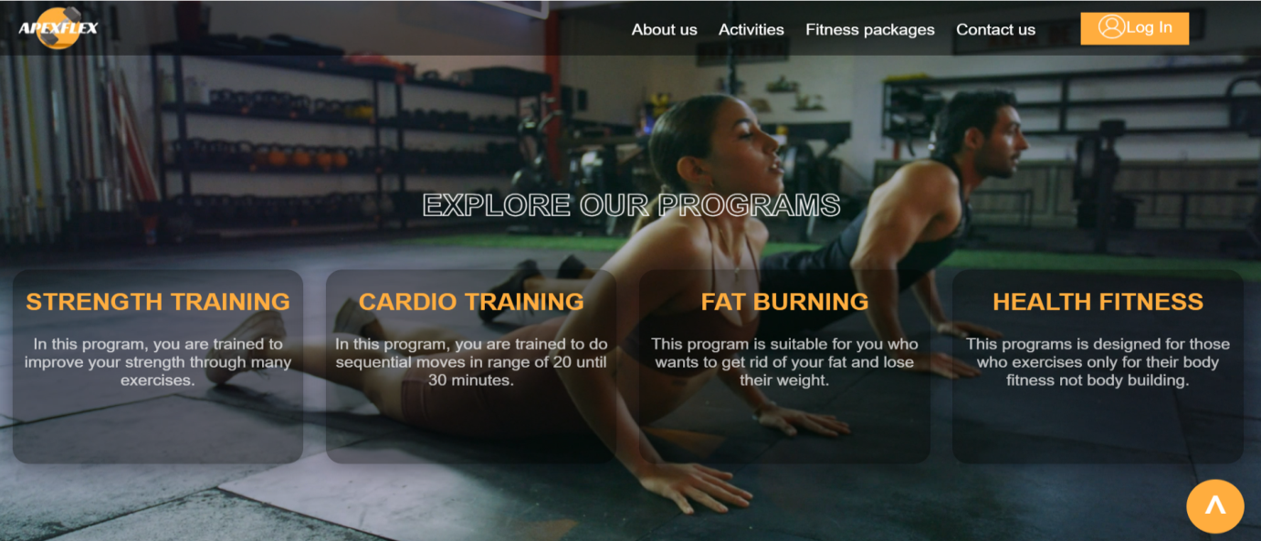

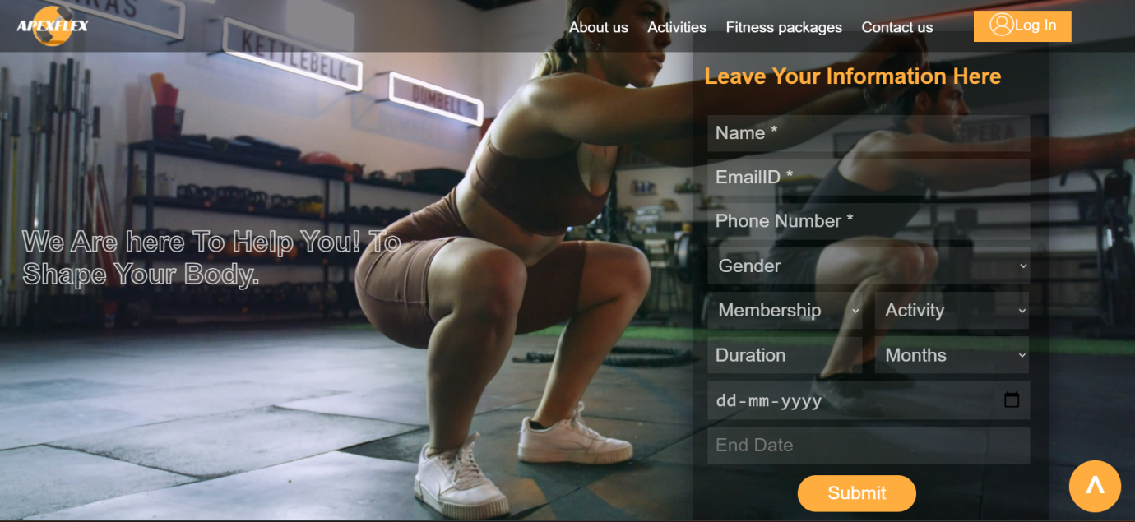

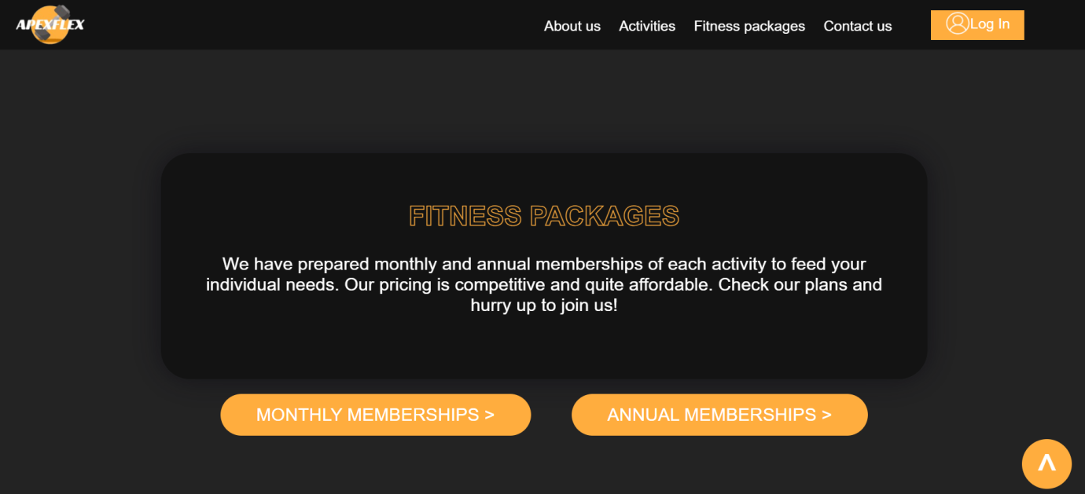

**NAV.PHP**

**ANNUALPACKAGE.PHP**

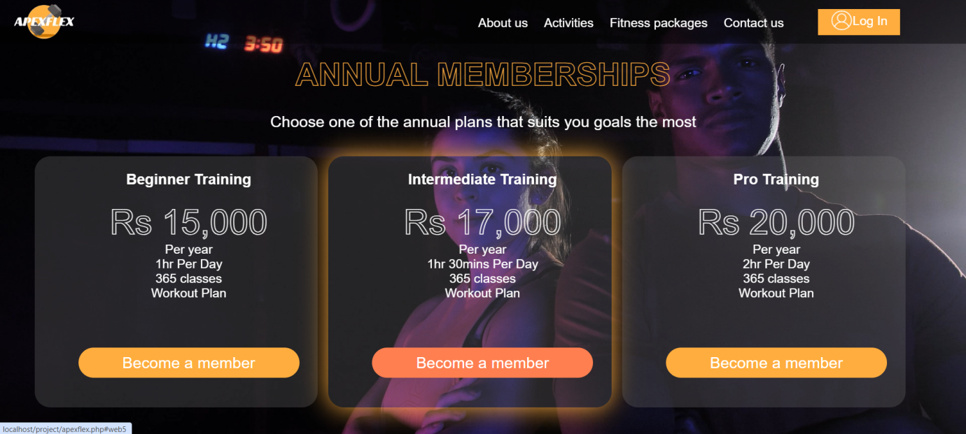

**MONTHLYPACKAGE.PHP**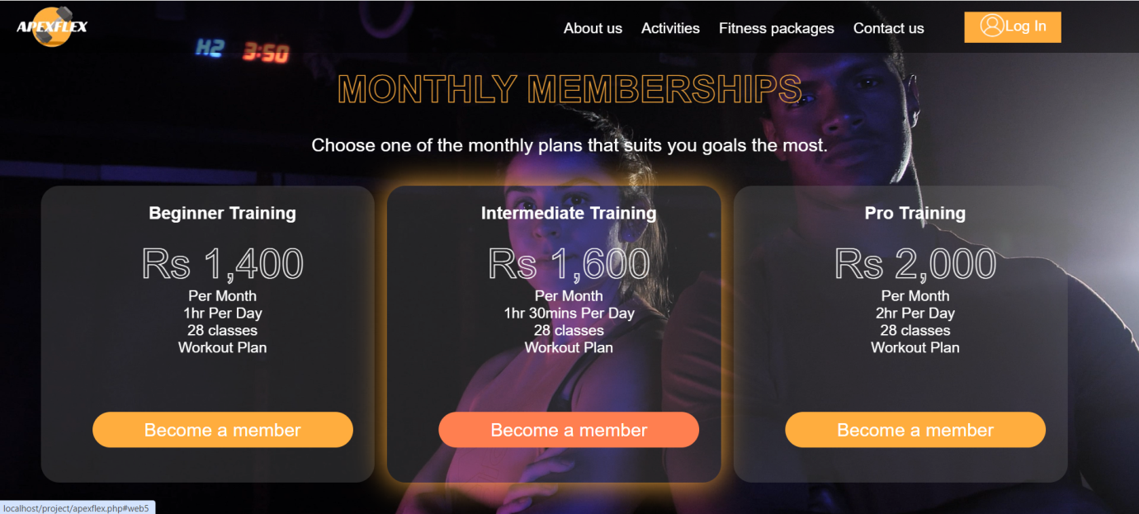

**SIGNUP.PHP**

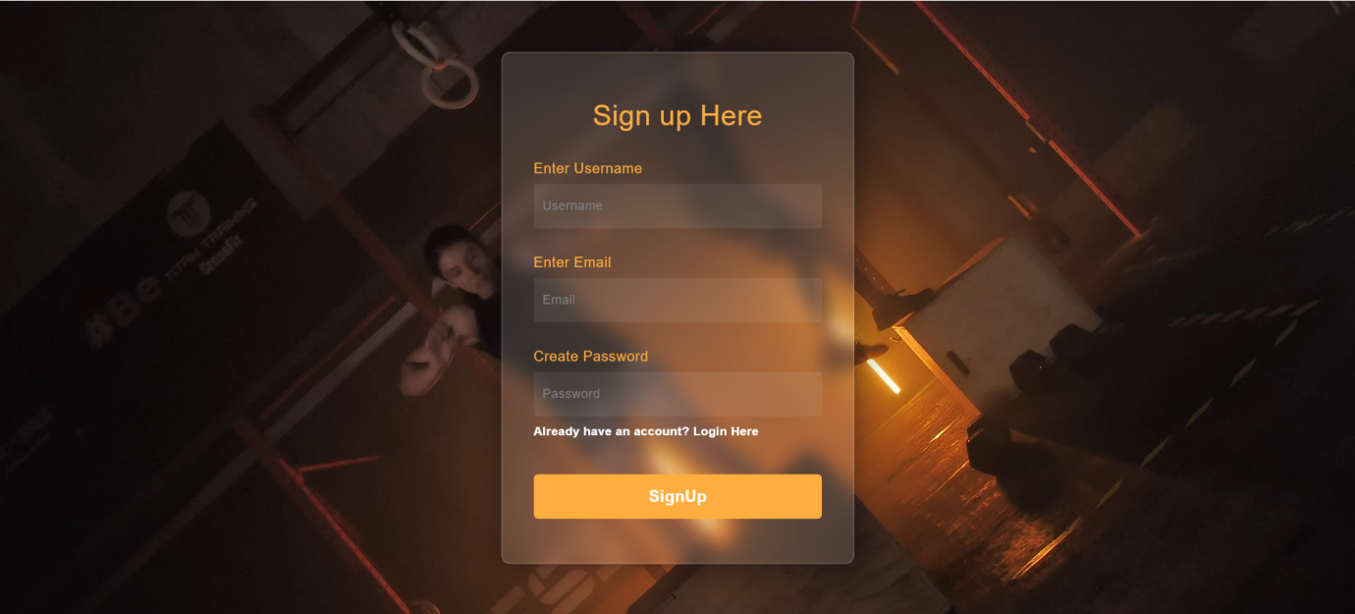

**LOGIN.PHP**

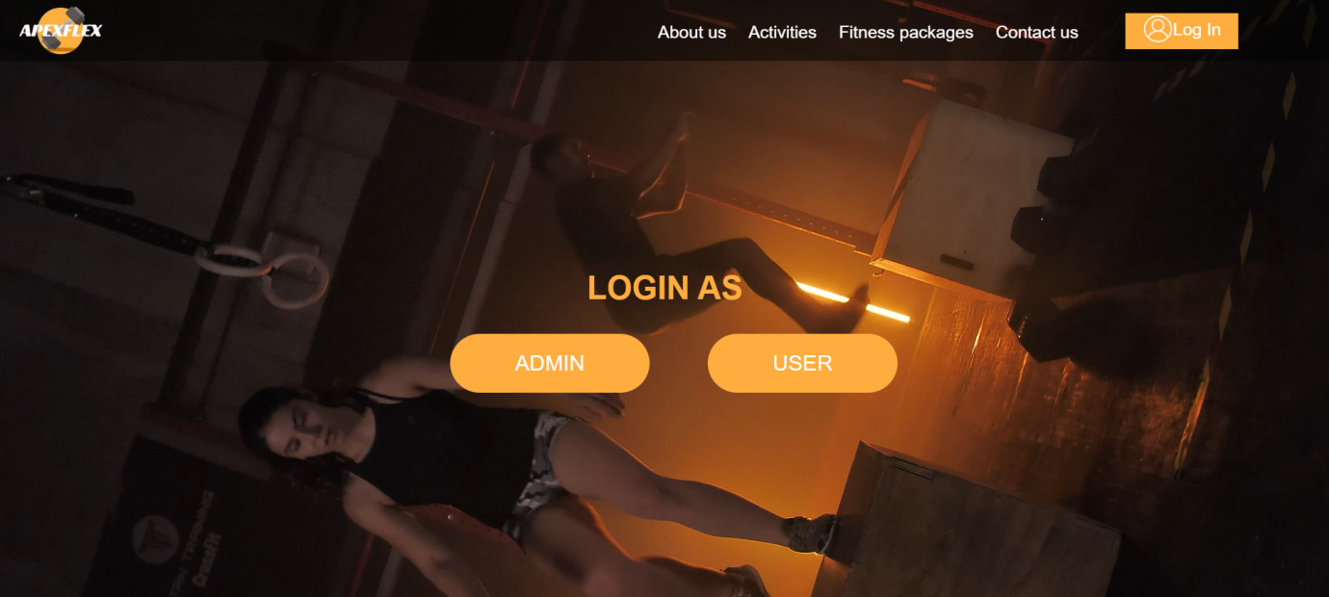

**ADMINLOGIN.PHP**

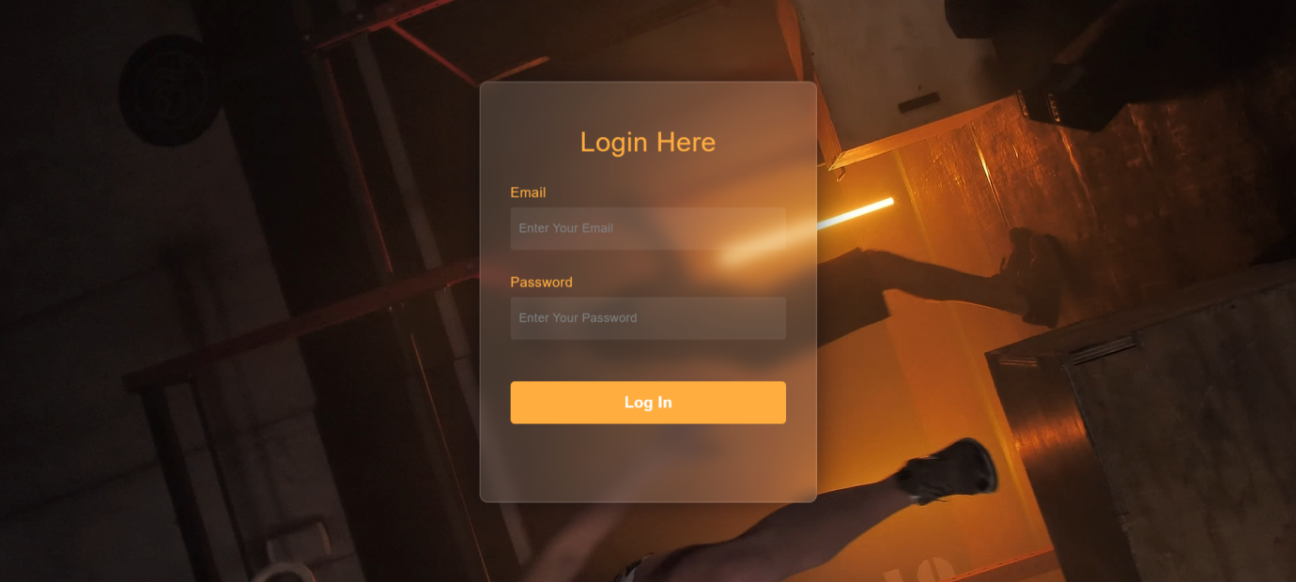

**USERLOGIN.PHP**

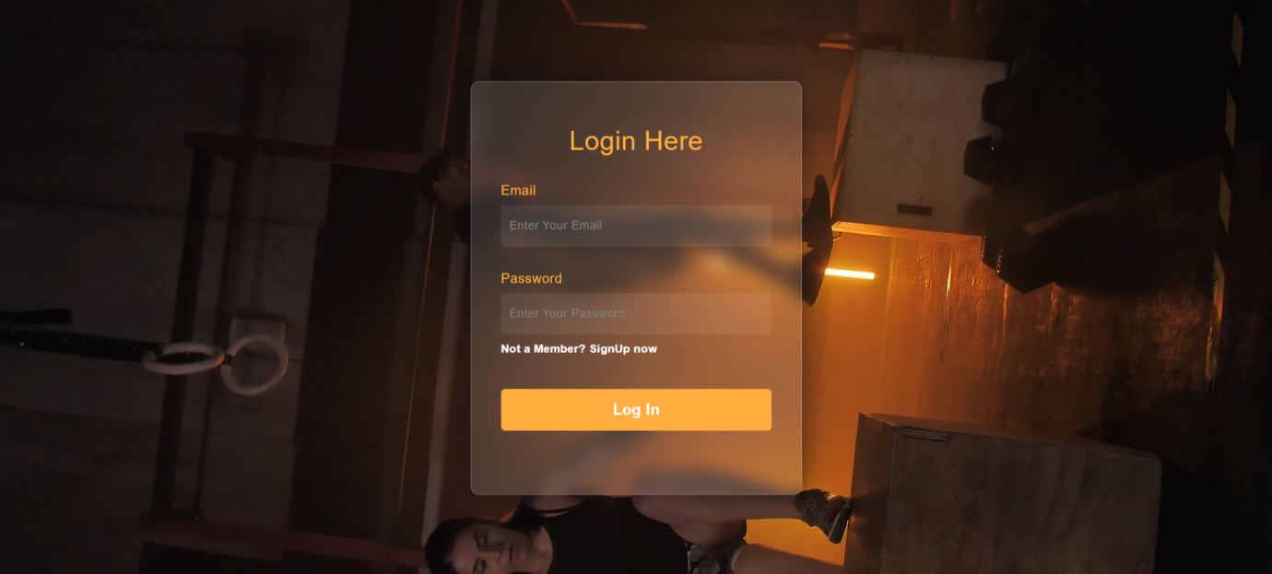

**ADMIN.PHP**

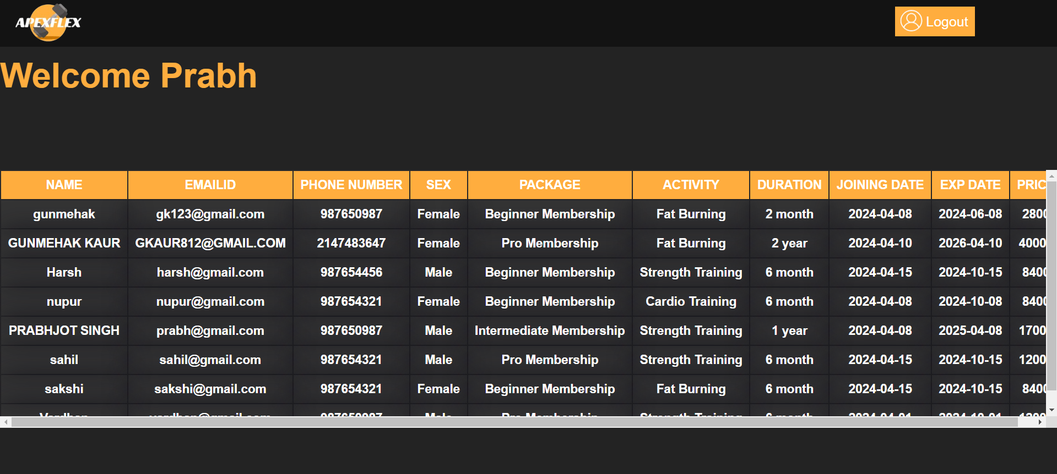

**USER.PHP**

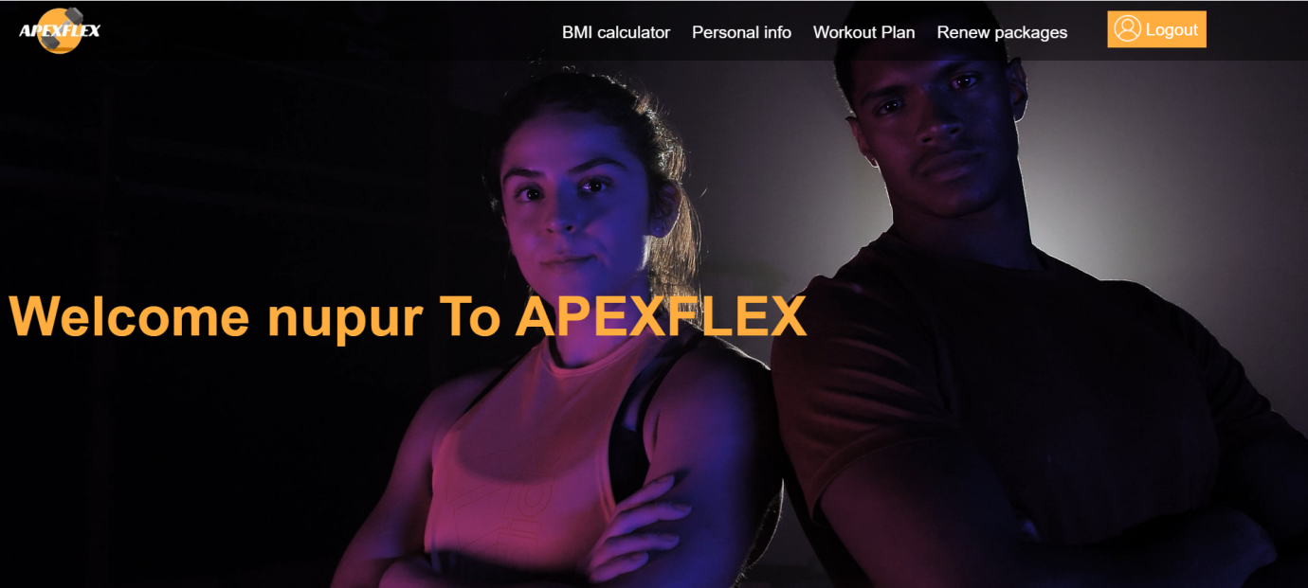

**USERINFO.PHP**

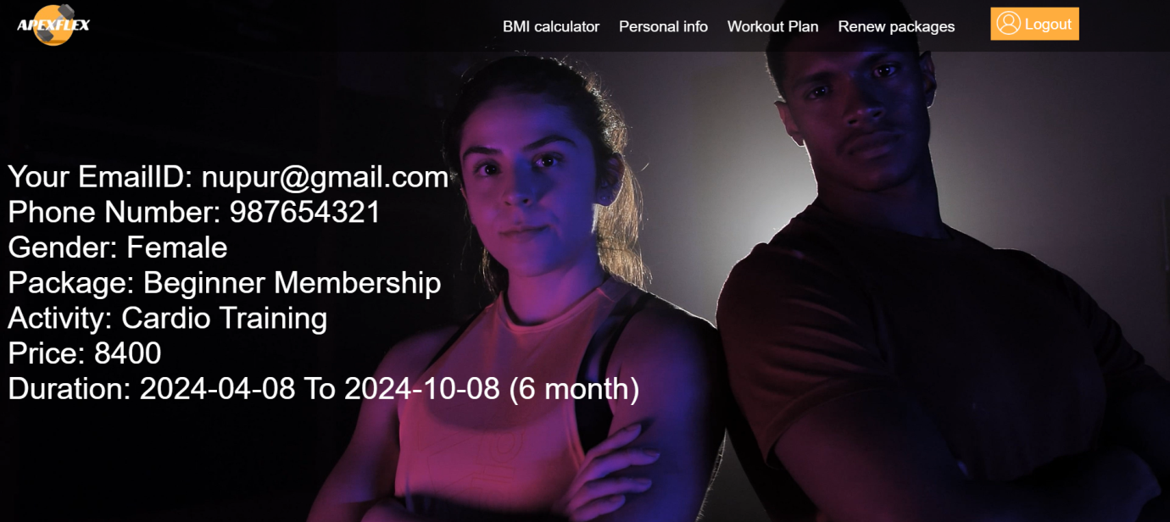

**BMI.PHP**

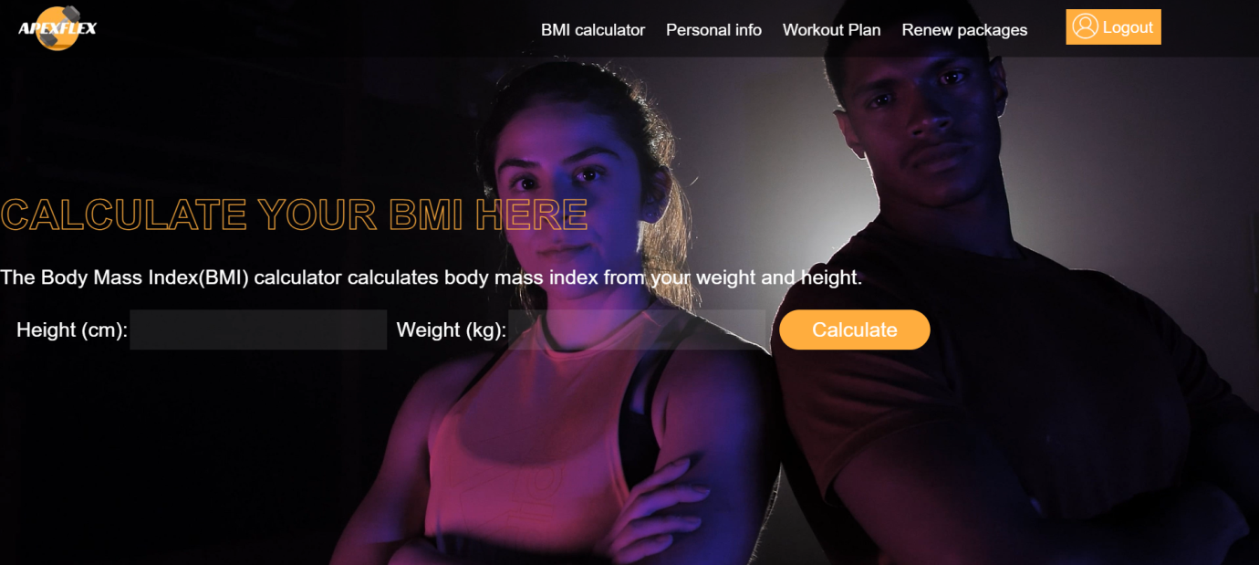

**WOROUTPLAN.PHP**

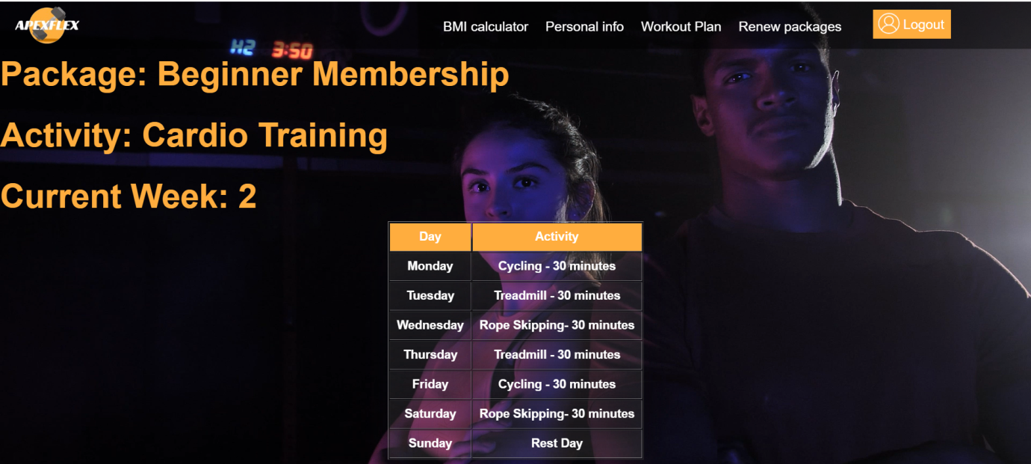

**REPACK.PHP**

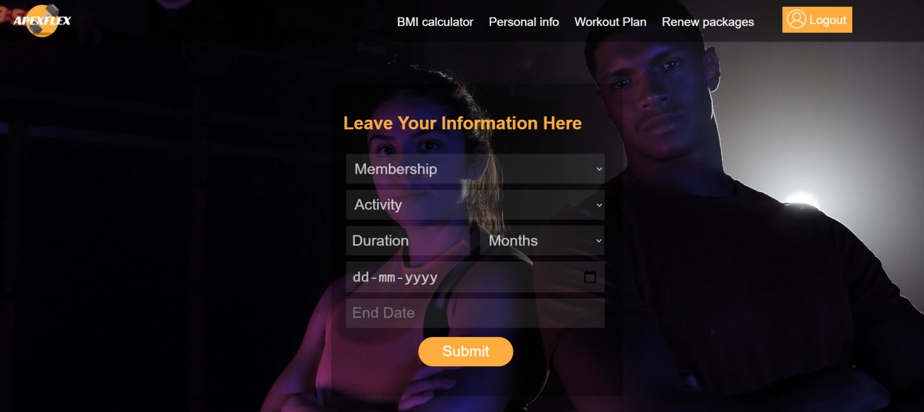

**MAINTENANCE MEASURES**

The maintenance of a gym website is essential to ensure its functionality, security, and user experience. To ensure the long-term sustainability and reliability of the APEXFLEX gym website, the following maintenance measures have been put in place:

**1. REGULAR CONTENT UPDATES:**

* Update workout packages and facility information regularly to keep members informed.
* Refresh images and videos to keep the website visually appealing and up to date with current trends.

**2**. **SOFTWARE UPDATES:**

* Regularly update the content management system (CMS) and plugins to the latest versions to ensure compatibility and security.
* Monitor for any software vulnerabilities and apply patches or updates promptly to mitigate risks.

**3.** **PERFORMANCE OPTIMIZATION:**

* Optimize images, minimize CSS and JavaScript files, and leverage caching mechanisms to improve page load times.
* Conduct periodic performance audits to identify and address any bottlenecks or issues affecting speed and responsiveness.

**4. SECURITY MEASURES:**

* Implement SSL encryption to secure data transmission and build trust with visitors.
* Install security plugins or firewalls to protect against malware, brute force attacks, and other security threats.
* Regularly scan for vulnerabilities and malware, and take immediate action to address any issues detected.

**5. BACKUP AND RECOVERY:**

* Set up regular automated backups of the website files and database to prevent data loss in the event of a server crash or security breach.
* Test backup restoration procedures periodically to ensure they are functioning correctly and can be relied upon in an emergency.

Regular maintenance of the gym website is crucial to ensure it remains secure, up to date, and user-friendly. By following the measures outlined in this report, the website can continue to attract and retain visitors while supporting the goals of the gym business.

**LIMITATIONS**

• The size of the database increases day-by-day, increasing the load on the database back up and data maintenance activity.

• Training for simple computer operations is necessary for the users working on the system.

• It don’t have any industrial implementation, it is just applicable to be implemented for small shops to main its shops products details

**CONCLUSION**

The APEXFLEX gym website project has been a successful exercise in designing and planning a comprehensive digital platform for a hypothetical fitness center. While APEXFLEX is not an actual operating gym, the website developed through this project serves as a model for how a modern, feature-rich gym website can be constructed.

It can be observed that computer applications are very important in every field of

human endeavor. Here all the information about customer that made reservation

can be gotten just by clicking a button with this new system, some of the

difficulties encountered with the manual system are overcome. The application also has the ability to update records in various files automatically thereby relieving the stress of working from file security of data

**FURTHER SCOPE OF THE PROJECT**

We think that not a single project is ever considered as complete forever. Because our mind is always thinking something new and our necessities also are growing day by day. We always want something more than what we have. Our application also, If you see at the first glance then you find it to be complete but we want to make it still mature and fully automatically. The future perspective of our project is to manage a gym automatically by adding sensor id’s, more defined workout and a well defined diet chart for each member according to their goal. Making a mobile app for the user is also a first step development. We can also change the security of the software over the time, because by the time software will have more and more secure as the data also secure. Overall, the APEXFLEX website demonstrates a well-designed and highly functional digital platform that effectively supports the typical goals of a gym business. The clean navigation, comprehensive content, and seamless user experience create a compelling online presence that could attract and engage prospective members.

**ANNEXURE’S**

**GYM WEBSITE:**

APEXFLEX

**OVERVIEW**

APEXFLEX is a gym website and web application designed to provide a comprehensive platform for gym members to manage their fitness routines, track their progress, and stay connected with the gym community. The website offers features such as class schedules, membership management, personal training bookings, and community forums.

**KEY FEATURES**

* Member Dashboard: Allows members to view their workout plan according to their fitness goal. Members can also update their profile information and preferences.
* Class Schedules: Displays the gym's class schedule, including description, and the ability to sign up for classes.
* Membership Management: Enables members to view and manage their membership details.
* Progress Tracking: Enables members to set fitness goals and monitor their progress, including BMI calculator.

**TECHNOLOGY STACK**

The APEXFLEX website is built using the following technologies:

* Front-end: HTML5, CSS3 and JavaScript
* Back-end: PHP
* Database: MySQL

**PROJECT TIMELINE**

The APEXFLEX project was completed over the course of 12 weeks, with the following timeline:

* Weeks 1-3: Requirements gathering and user research.
* Weeks 4-6: Front-end development and integration with the back-end.
* Weeks 7-9: Back-end development, including API design and database integration.
* Weeks 10-12: Testing, bug fixing.

**PROJECT TEAM**

The APEXFLEX project was developed by a team of 2 college students:

* Nupur - Front-end Developer
* Prabhjot Singh - Back-end Developer

The APEXFLEX gym website has been well-received by the college community, providing a user-friendly and comprehensive platform for managing fitness activities and staying connected with the gym. The project has been a valuable learning experience for us, allowing us to apply our technical skills and work collaboratively to deliver a functional website.

**BIBLIOGRAPHY**

For PHP

* <https://www.w3schools.com/php/default.asp>
* <https://www.sitepoint.com/php/>
* <https://www.php.net/>

For MySQL

* <https://www.mysql.com/>
* <http://www.mysqltutorial.org>

For XAMPP

* https://www.apachefriends.org/download.html